Wesley Roy Sprunger
February 24, 1891 – March 30, 1952

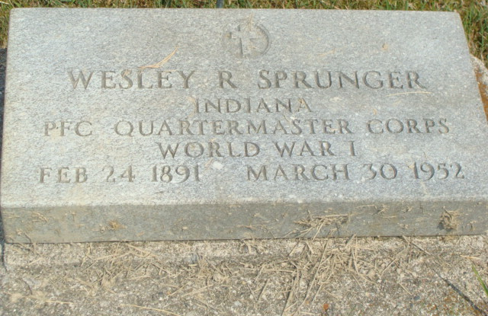
Photo by Alicia Kneuss

W. R. SPRUNGER DIES SUNDAY AT VET'S HOSPITAL
Kidney Ailment Fatal to Former Local Business Man; Rites Wed.
Wesley R. (Ziggy) Sprunger, 61, operator of The Clothes Shop here for many years, and later a cabinet maker and carpenter, died at 6:30 a.m. Sunday at the Veterans Hospital in Fort Wayne. Death was attributed to uremic poisoning and followed a long illness of kidney trouble. Mr. Sprunger had been in the hospital one month and five days. He submitted to surgery to one of his kidneys on March 7.
Following the operation Mr. Sprunger's condition was serious for a few days, but then he rallied and was thought to be making fine progress. The middle of last week his condition was described as much improved. His condition was good Saturday morning, but slipped rapidly and by Saturday evening his condition was critical. He lapsed into a coma Saturday noon. The poison spread rapidly and all medical efforts failed.
Mr. Sprunger had suffered with a kidney ailment and kidney stones for 20 years. Both kidneys were affected and this greatly hampered his chances for recovery. Mr. Sprunger had been unable to work since last November.
Mr. Sprunger owned and operated The Clothes Shop for many years. He sold it to the present owner, Ervin Schindler, in 1946. Mr. Sprunger was regarded as one of the top-notch tailors in this community for many years. He started The Clothes Shop in 1918, soon after returning from the Army. He saw service in World War I from April 3, 1918 to Feb. 28, 1919. He was overseas. Before entering the Army, he was in the dry-cleaning business briefly and when he returned from the service, he started up his business. After selling the shop in 1946, he engaged in cabinet work and also did carpenter work.
Mr. Sprunger was born in Monroe Township, north of Berne, February 24, 1891. He was the son of Christian C. and Rosina Reusser Sprunger. He graduated from the Berne High School and attended Angola Normal School. Mr. Sprunger was an outstanding tennis player during his high school and college days and also later.
He was married to Florence Grime of Pioneer, Ohio, on August 5, 1917. She survives, together with the following children: Avery, Fort Wayne; Mrs. Ben (Louise) Howell, Dayton, Ohio; Richard, Tuscaloosa, Alabama; Mrs. C. S. (Patricia) McGee, Houston, Texas; Thomas, Dayton, Ohio, and Kent, with the U.S. Army in Germany. There are eight grandchildren and the following brothers and sisters: Asa, Mendota, Illinois; Oswald, Decatur; Victor, Monroe Township, north of Berne; Paul, Milwaukee, Wisconsin; Mrs. A. J. (Bessie) Neuenschwander, Wadsworth, Ohio; Mrs. Ferd (Rena) Reusser, Deer Creek, Okla.; and Mrs. M. A. Thomas, Union City. One sister preceded in infancy.
Mr. Sprunger was a member of the First Mennonite Church where funeral services will be held at 2:00 p.m. Wednesday, Rev. C. A. Schmidt, pastor of the Cross Evangelical and Reformed Church officiating in the absence of the pastor, Rev. O. A. Krehbiel. Burial will be in the M.R.E. Cemetery. The body was removed from the Yager Funeral Home to the Sprunger residence at 806 N. Sprunger Street, where friends may call.
Adams County, Indiana Historical Museum
1951 Nov - Apr 1952 Scrapbook, Image 43
Handwritten-Mon. March 31, 1952

