Walter Sprunger
January 1, 1889 – October 15, 1918

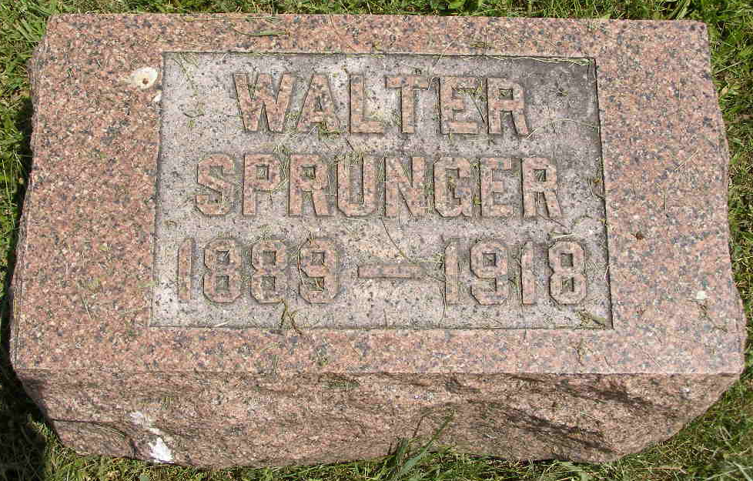
Photo by Shaunda Bedwell Opdycke

Body Arrives At Berne

(Special to the News) DECATUR, Ind., Oct. 19 - The body of Walter Sprunger, 29, arrived from Fort Leavenworth, Kas., and was taken to the home of the parents, Mr. and Mrs. Ulrich Sprunger, north of Berne, where the funeral will be held Saturday afternoon at 2 o'clock. His death occurred from pneumonia. Word of the death was the first word the parents had received since he was transferred recently from Camp Taylor, Ky., he being one of the conscientious objectors from the community.

The Fort Wayne News and Sentinel, Allen County, Indiana
October 19, 1918
**

U.S., WPA Birth Index, 1880-1920

Name Springer
Gender Male
Birth Date 1 Jan 1889
Birth Place Adams, Indiana, USA
Father Ulrich Springer
Mother Anna Liechty
Book H-1
Page 306

