Wanda Sue (Griffin) Sprunger
January 18, 1948 – August 18, 2011

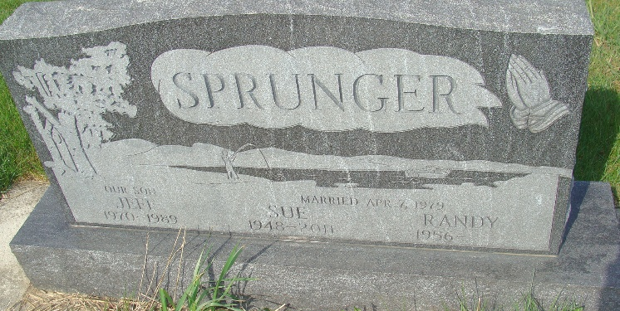
Photo by Alicia Kneuss

Wanda Sue Sprunger, 63, of Berne, Indiana died at her residence on Thursday, August 18, 2011. Wanda was born on January 18, 1948 in Kennett, Missouri to the late Cecil and Juanita (Harrison) Griffin. She married Randy L. Sprunger on April 7, 1979. Wanda was a member of the Bethel Brethren Church in Berne. She was a homemaker and a receptionist at Amy's Professional Hair in Berne. She is survived by her husband Randy L. Sprunger of Berne; two brothers Bill (Linda) Griffin of Malverne, Ark. and Larry (Carol) Griffin of Salem, IL; a sister Clara Taylor of Salem, IL. She was preceded in death by her son Jeff and two sisters. Visitation will be from 2-6 p.m. on Sunday, August 21, 2011 at Bethel Brethren Church Fellowship Hall in Berne and 1 hour prior to services. A Memorial funeral service will be on Monday, August 22, 2011 at 2:00 p.m. also at the church. Rev. Joe Nass will be officiating. Preferred memorials are to Bethel Brethren Church.

Unknown source
**

Indiana, U.S., Death Certificates, 1899-2017

Name Wanda Sue Sprunger
[Wanda Sue Griffin]
Maiden Name Griffin
Gender Female
Race White
Marital Status Married
Age 63
Birth Date 18 Jan 1948
Birth Place Kennet, Missouri
Death Date 18 Aug 2011
Death Place Berne, Adams, Indiana, USA
Death Registration Date 2011
Father Cecil Griffin
Mother Juanita Harrison
Spouse Randy L Sprunger, informant
Burial MRE Cemetery

