Della Dora (Lehman) Sprunger-Von Gunten
July 11, 1893 – December 17, 1978

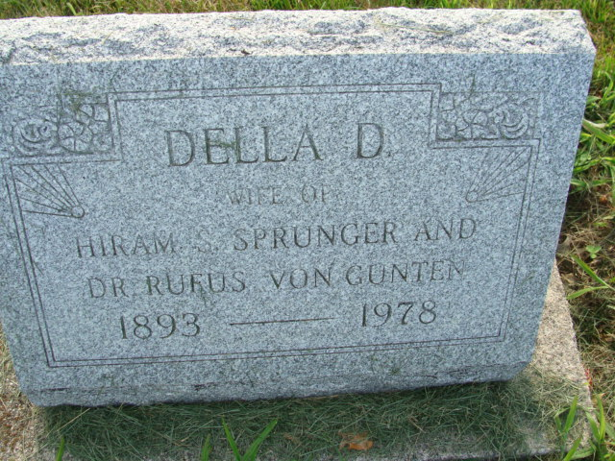
Photo by Alicia Kneuss

Indiana, U.S., Death Certificates, 1899-2017
Name Della D VonGunten
[Della D Lenman]
Gender Female
Race White
Marital Status Widowed
Age 86
Birth Date 11 Jul 1892
Birth Place Indiana
Death Date 17 Dec 1978
Death Place Bluffton, Wells, Indiana, USA
Death Registration Date 1978
Father David F Lehman
Mother Emma Sprunger
Informant Gordon T. Sprunger, Berne, IN
Burial M.R.E. 12/19/1978
**

Indiana, U.S., Marriage Certificates, 1960-2012

Name Della D Lehman
Gender Female
Marriage License Date 7 Nov 1914
Marriage Date 3 Nov 1914
Marriage Place Adams, Indiana, USA
Spouse Hiram S Sprunger

