Vivian F. (Gottschalk) Sprunger
February 18, 1923 - December 30, 2013

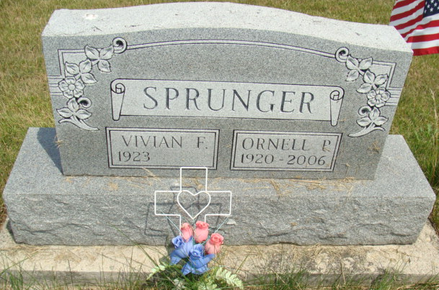
Photo by Alicia Kneuss

Vivian F. Sprunger, 90, Berne, passed away December 30, 2013 at Swiss Village. She was born to Clemet and Mahala (Reusser) Gottschalk on February 18, 1923 in Adams County. She married Ornell Sprunger on January 27, 1946.
Vivian was a homemaker and a member of the First Missionary Church where she sang in the choir and served on the hospitality committee. She also worked at the G.E. plant in Decatur. Her interests include; gardening, needlework, and solving word puzzles.
Survivors are four children: daughters, Myrna (Ladd) Wheeler of Crofton, MD., Betty Sprunger of Peru, IN., sons, Ted (Jan) Sprunger of Fort Wayne, Bob (Sara) Sprunger of Berne, 8 grandchildren, 1 step-grandchild, 4 great-grandchildren, 4 step-great-grandchildren, sister, Marjorie DeArmond of Berne.
Preceding in death are her parents, husband, Ornell, sister, Phyllis Conrad and a brother, Rev. Truman Gottschalk.
Funeral services are pending at Yager-Kirchhofer F. Home. Burial is in the M.R.E. Cemetery in Berne. Preferred memorials are to the First Missionary Church &/or World Team (ministry in Brazil, S.A.).

Yager-Kirchhofer Funeral Home, Adams County, Indiana
December 30, 2013

