Virginia M. (Schwartz) Sprunger
December 26, 1922 – January 26, 2002

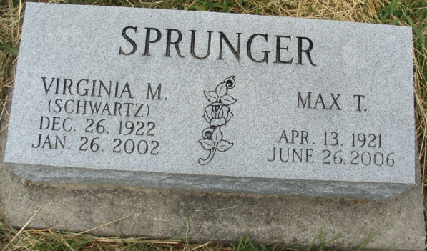
Photo by Alicia Kneuss

VIRGINIA M. SPRUNGER, 79, of Elkhart, formerly of Berne, died Saturday at Elkhart General Hospital. Born in Berne, she was a homemaker and food service director at Camp Friedenswald, Shavehead Lake, Michigan, and at Oaklawn Psychiatric Center. Surviving are her husband, Max T.; a daughter, Ann Sprunger of Ann Arbor, Mich.; four sons, Lewis of Portland, Ore., Joseph of Metuchen, N.J., Jonathan of Dundee, Ohio, and Edmund of New York; eight grandchildren; two sisters, Anna Jane Gilliom of Bluffton and Gertrude Kropa of Centerville, Mass.; a brother, Larry Schwart of Indianapolis; and a stepsister, Colleen Allmandinger of Berne. Memorial services at 11 a.m. Saturday at Hively Avenue Mennonite Church, Elkhart. Calling two hours before services. Burial at a later date. Memorials to Camp Friedenswald or Hivley Avenue Mennonite Preschool. Arrangements by Hartzler-Gutermuth-Inman Funeral Home, Elkhart.

Journal Gazette, The (Allen County, Indiana)
Tuesday, January 29, 2002
**

Max Truman Sprunger in the Lancaster, Pennsylvania, U.S., Mennonite Vital Records, 1750-2014

Name Max Truman Sprunger
Relationship Head
Birth Date 13 Apr 1921; Birth Place Berne, Indiana, USA
Marriage Date 26 Mar 1942
Death Date 26 Jun 2006; Death Place Goshen, Indiana, USA
Household Members (Name) Relationship
Max Truman Sprunger Head
Martin L. Sprunger Father
Linda C. Luginbill Mother
Virginia Mae Schwartz Spouse
Christian W. R. Schwartz Father-in-law
Minnie Sprunger Mother-in-law

