Virgil Lloyd Sprunger
July 28, 1923 – September 27, 2000

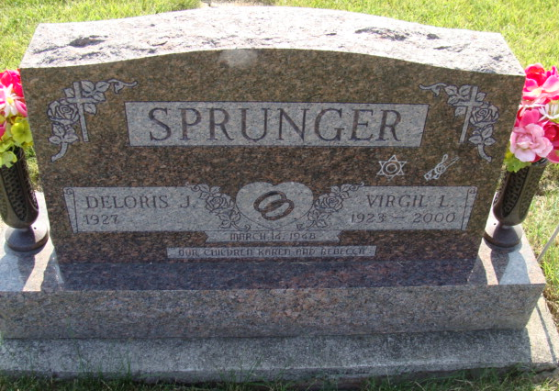
Photo by Alicia Kneuss

Virgil L. Sprunger, 77, of Monroe, who served as town marshal from 1980-1999, died Wednesday, Sept. 27, 2000, at Adams County Memorial Hospital in Decatur. The Fort Wayne native was a member of Bluffton First Church of the Nazarene and was a Navy veteran.
Surviving are his wife, Deloris; daughters Karen Kistler of Holiday, Fla., and Becky Behning of Markle; sisters Rosanna Wanner of Geneva and Christine Burch of Colfax, N.C.; brothers Donald of Berne and Joe of Fort Wayne; seven grandchildren; and three great-grandchildren.
Services are 11 a.m. Friday at Bluffton First Church of the Nazarene, Bluffton, with calling from 9:30 a.m. until services. Calling is also from 2 to 9 p.m. today at Haggard & Sefton Funeral Home, Decatur. Burial will be at M.R.E. Cemetery, Berne.
Memorials are to the church Building Fund. Information provided by Haggard and Sefton Funeral Home, Decatur, 1-219-724-7167.

News-Sentinel, The (Allen County, Indiana)
Thursday, September 28, 2000

