Vincent W. Sprunger
April 8, 1912 – January 4, 1995

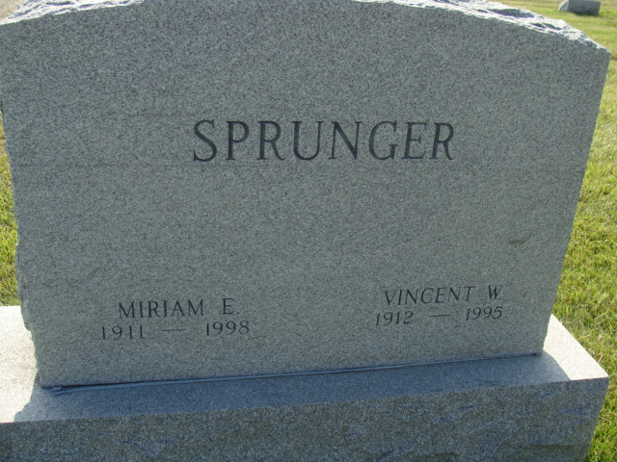
Photo by Alicia Kneuss

Indiana, U.S., Death Certificates, 1899-2017

Name Vincent W Sprunger
Gender Male
Race White
Marital Status Married
Age 82
Birth Date 8 Apr 1912
Birth Place Nebraska
Death Date 4 Jan 1995
Death Place Berne, Adams, Indiana, USA
Death Registration Date 1995
Father Nathan Sprunger
Mother Caroline Schiedegger
Spouse Miriam (Yeoman) Sprunger, informant
Burial 1/8/1995 M.R.E.

