Victor Peter Sprunger
February 10, 1898 – February 27, 1986

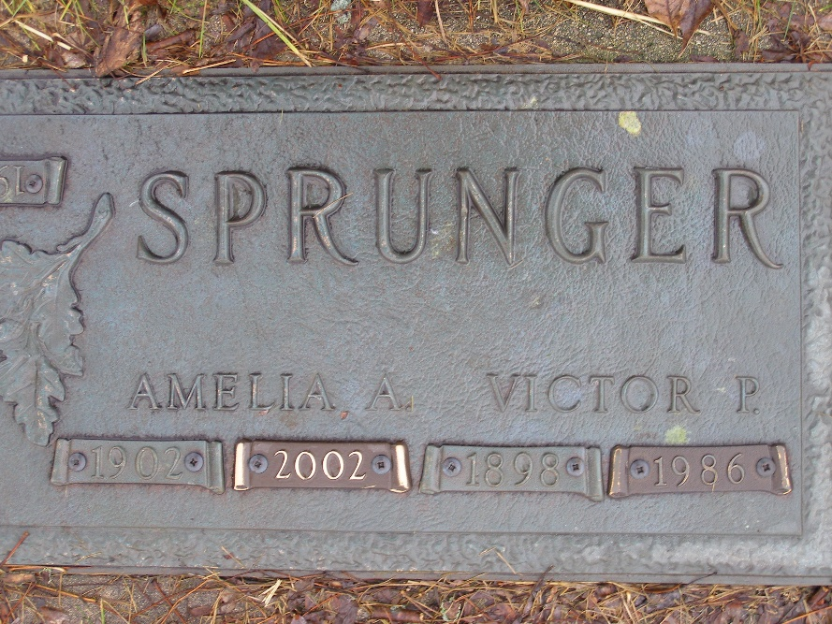
Photo by Shaunda Bedwell Opdycke

Michigan, U.S., Death Index, 1971-1996
Name Victor P Sprunger
Birth Date 10 Feb 1898
Death Date 27 Feb 1986
Gender Male
Residence Waterford, Oakland, Michigan
Place of Death Pontiac, Oakland, Michigan
**

Indiana, U.S., Marriages, 1810-2001

Name Victor Sprunger
Gender Male
Race White
Age 25
Event Type Marriage Registration (Marriage)
Birth Date 10 Feb 1898
Birth Place Berne, Indiana
Marriage Date 22 Dec 1923
Marriage Place Indiana, United States
Residence Place Bluffton, Indiana
Father B C Sprunger
Mother Rosene Russel
Spouse Amelia Baumgartner
Page 171

