Vernon L. Sprunger
August 8, 1923 – July 5, 1985

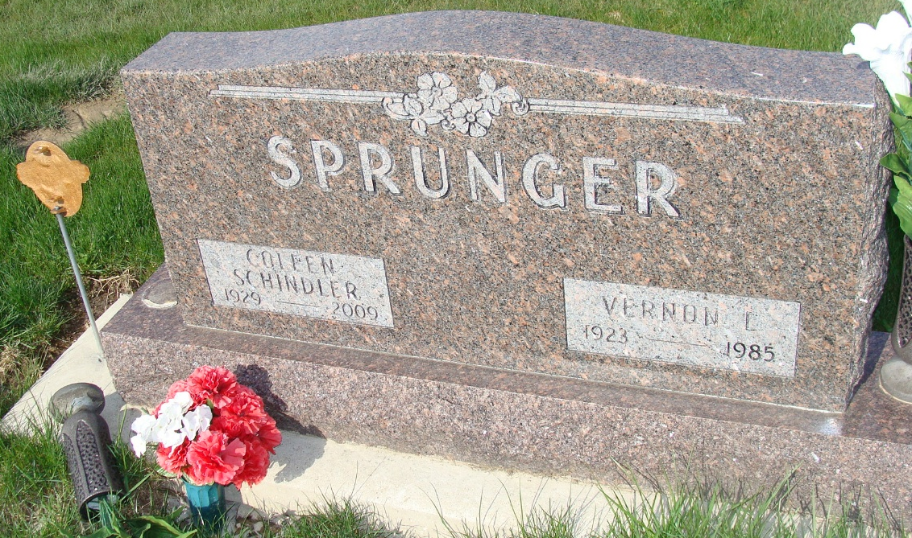
Photo by Alicia Kneuss

Indiana, U.S., Death Certificates, 1899-2017

Name Vernon Sprunger
Gender Male
Race White
Marital Status Married
Age 61
Birth Date 8 Aug 1923
Birth Place Indiana
Death Date 5 Jul 1985
Death Place Fort Wayne, Allen, Indiana, USA
Death Registration Date 1985
Father Alfred Sprunger
Mother Robertine Liechty
Spouse Coleen (Schindler) Sprunger, informant
Burial MRE 7/8/1985

