Vernon Jacob Sprunger
June 3, 1904 – December 27, 1980

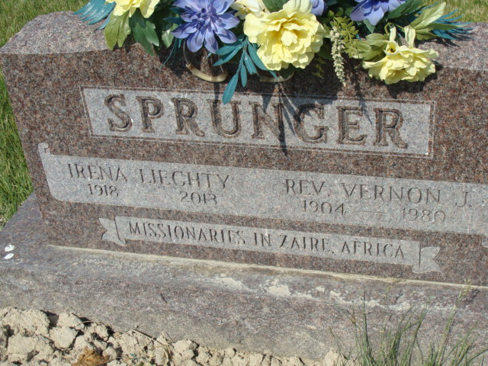
Photo by Alicia Kneuss

Indiana, U.S., Death Certificates, 1899-2017

Name Vernon L. Sprunger (Vernon J. on tombstone)
Gender Male
Race White
Marital Status Married
Age 76
Birth Date 3 Jun 1904
Birth Place Ohio
Death Date 27 Dec 1980
Death Place Fort Wayne, Allen, Indiana, USA
Death Registration Date 1980
Father Noah Sprunger
Mother Rosa Amstutz
Spouse Irena (Liechty) Sprunger, informant
Burial M.R.E. 12/30/1980

