Vernelle M. Sprunger
September 20, 1916 – October 1, 1921

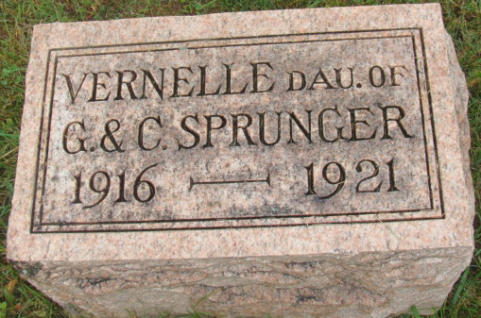
Photo by Alicia Kneuss

Indiana, U.S., Death Certificates, 1899-2017

Name Vernelle M. Sprunger (indexed as Springer)
Gender Female
Race White
Marital Status Single
Age 5y 11d
Cause of death tetanus – nail in foot
Birth Date 20 Sep 1916
Birth Place Ft. Wayne Allen Co Indiana
Death Date 1 Oct 1921
Death Place Ind, Adams, Indiana, USA
Death Registration Date 1921
Father George Sprunger, informant
Mother Carrie Badertcher
Burial M.R.E. Cem. 10/3/1921

