Verna L. (Nussbaum) Sprunger
June 7, 1924 – April 17, 2014

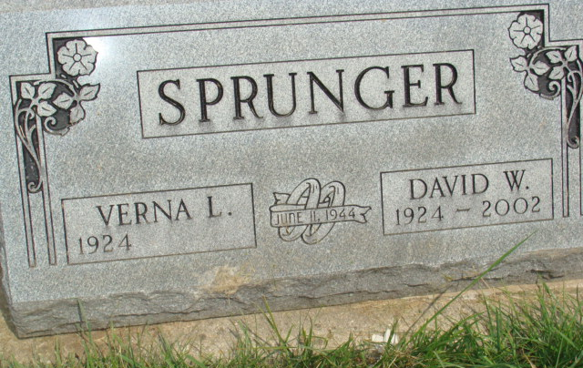
Photo by Alicia Kneuss

Verna L. Sprunger, 89, Berne, passed away Thursday, April 17, 2014 at Adams Memorial Hospital, Decatur. She was born to Harvey and Emma (Habegger) Nussbaum on June 7, 1924 in Adams County, Indiana. She married David Sprunger on June 11, 1944.
Verna was a member of the First Mennonite Church where she was a member of the kitchen committee and co-chairman of the assistance committee. She was employed at South Adams Schools as a cafeteria cook and also an inspector at Berco Co. Special interests include quilting and needlework.
Survivors include: four daughters; Ruth (Von) Bixler of Decatur, Twyla and Jean Spunger of Berne, Judith (Terry) Fralick of Convoy, Oh., son, Rick (Sue) Sprunger of Berne, 7 grandchildren, Bobbie (Robert) Reichhart, Loree Sprunger, Kristine (Phil) Kunes, Amanda (Andrew) Caffee, Nathan Sprunger, Tim and Jon Fralick, great grandchildren, Parker and Drew Reichhart , a sister, Emma Jane (Rev. Roger) Bixler of Berne. Preceding in death are her parents, husband, son, Wayne Sprunger and brother, Truman Nussbaum.
Funeral services are Tuesday, April 22 at 10:30 am at the First Mennonite Church Chapel with visitation 1 hour prior to services. Officiating is Pastor Jeff Linthicum and Pastor Roger Bixler. Visitation also Monday from 3 to 8 pm at the Yager-Kirchhofer Funeral Home, Berne. Burial is in the M.R.E. Cemetery.
Preferred memorials are to the MCC Canner &/or Gideon's International.

Yager-Kirchhofer Funeral Home, Adams County, Indiana
April 18, 2014

