Verna Louise (Baumgartner) Sprunger
December 18, 1920 – May 11, 2024

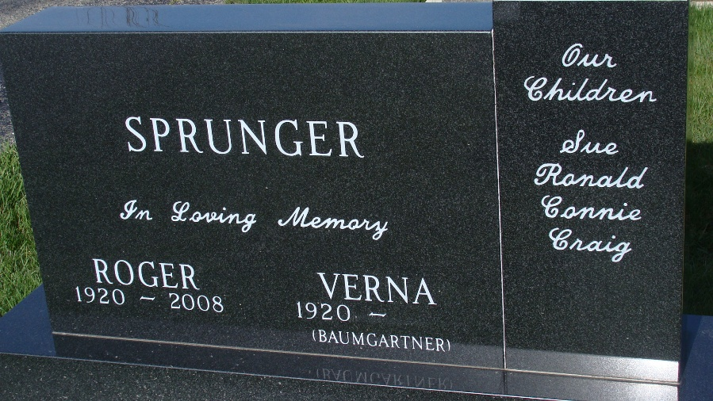
Photo by Alicia Kneuss

Verna Louise Sprunger, 103, of Berne, Indiana was welcomed home to her Lord and Savior on Saturday morning, May 11, 2024, at Swiss Village in Berne. She was born on December 18, 1920, in Berne, Indiana to the late Elmer Walter Baumgartner and Bertha (Lehman) Baumgartner. Verna was united in marriage to Roger L. Sprunger on November 7, 1942, and he preceded her in death on December 12, 2008.
She was a longtime member of the First Mennonite Church in Berne, Indiana she was baptized and joined the church in 1934. She loved music and spent many years singing in the Chancel Choir, Ladies Sextet, many of the Mennonite Choral Society presentations, including the Messiah and the Creation. She also taught children’s Sunday school, helped create many quilts for missions and served in the migrant ministry. She was a volunteer in many community organizations including Swiss Heritage, Fine Arts Counsel, and President of the Berne Mother’s Club. She was formerly employed at the First Bank of Berne.
Verna valued and loved being with family and was a devoted wife, mother, grandmother, and great-grandmother. Her children, grandchildren, and great-grandchildren were a special joy to her and she invested much time, care, and love in them. Her Christian faith was the foundation of her life and many felt her unconditional love that resulted from her faith in Christ.
She is survived by her son, Ronald (Karleen) Sprunger of Berne, Indiana; son, Craig (Lora) Sprunger of Berne, Indiana; daughter, Sue (James) Bergstrom of West Lafayette, Indiana; daughter, Constance (David) Sewell of Columbia City, Indiana; brother, Howard Baumgartner of Berne, Indiana; 10 grandchildren; and 25 great-grandchildren.
Verna was preceded in death by in death by three sisters, Elaine Lantz, Marjorie C. Sprunger, and Eddyth L. Reusser and two sisters-in-law, Maxiene Lantz and Phyllis Baumgartner.
The Memorial Service for Verna will be held at 11:00 a.m. Friday, May 17, 2024, at the First Mennonite Church in Berne, Indiana with Pastor Jim Schwartz officiating. A private family committal service will precede the service at the church at M.R.E. Cemetery in Berne, Indiana. The family will receive friends from 4:00 to 7:00 p.m. Thursday, May 16, 2024, at the Swiss Village Chapel and one hour prior to the service at the church Friday.
Preferred memorials can be given to the First Mennonite Church or the Mennonite Choral Society.

Zwick & Jahn Funeral Homes, Adams County, Indiana
May 12, 2024

