Verena Elizabeth (Sprunger) Sprunger
October 15, 1916 – November 9, 2009

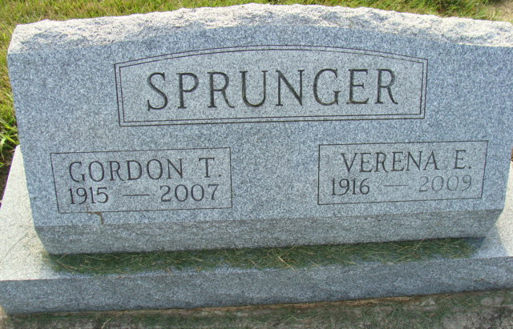
Photo by Alicia Kneuss

Verena Sprunger, 93, of Berne, Indiana passed away at 9:25 p.m. Monday, November 9, 2009 in the Swiss Village Retirement Community in Berne, Indiana. Verena was born on October 15, 1916 in Adams County, Indiana the daughter of Theodore and Rosina (Nussbaum) Sprunger, both deceased. She married Gordon T. Sprunger on April 9, 1939 and he preceded her in death on 2007.
Verena was a member of the First Mennonite Church in Berne, Indiana where she was a Sunday School Teacher. She was retired from Dunbar Furniture and Berne Furniture Company where she worked in the office.
Verena is survived by a son, David (Lori) Sprunger of Roanoke, Indiana; a son, Barton (Judy) Sprunger of Indianapolis, Indiana; and a daughter, Mary (Peter) Sprunger-Froese of Colorado Springs, Colorado. Other survivors include five grandchildren and four great-grandchildren.
Verena was preceded in death by her husband Gordon and three brothers, Sherwood, Willard, and Marion Sprunger.
A funeral service will be held at 1:30 p.m. Saturday, November 14, 2009 in the Swiss Village Chapel with the Rev. Jerry Flueckiger officiating. Interment will be in the M.R.E. Cemetery of rural Berne. Family and friends will be received from 10:00 a.m. – 12:00 noon on Saturday, November 14 in the Swiss Village Chapel.
Preferred memorials are to the Swiss Village Samaritan Fund.

Yager-Kirchhofer Funeral Home, Adams County, Indiana

