Velma Verl (Nichols) Sprunger
March 16, 1900 – June 2, 1948

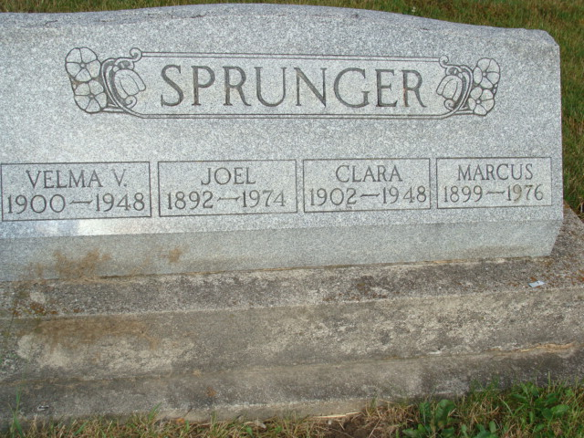
Photo by Alicia Kneuss

Indiana, U.S., Death Certificates, 1899-2017
Name Mrs Velma Verl Nichols Sprunger
[Mrs Velma Verl Nichols Nichols]
Gender Female
Race White
Marital Status Married
Age 48y 2m 16d
Birth Date 16 Mar 1900
Birth Place Indiana
Death Date 2 Jun 1948
Death Place Monroe, Adams, Indiana, USA
Death Registration Date 1948
Father Forest Nichols
Mother Emma Yoder Nichols
Spouse Joel Sprunger, informant
Burial 6-5-1948 M. R. E.

