Velma R. Sprunger
April 17, 1906 – January 12, 1993

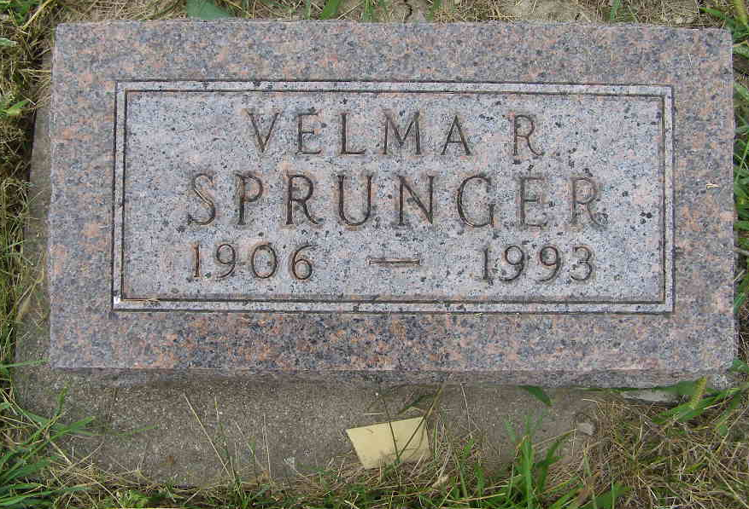
Photo by Shaunda Bedwell Opdycke

Velma Ruth Sprunger from tree Fahlsing Family Tree

Birth 17 Apr 1906 Indiana, USA
Residence 1920 Monroe City, Adams, Indiana, USA
Death 12 Jan 1993 Tahlequah, Cherokee, Oklahoma, USA
Father Daniel John Sprunger (1873-1945)
Mother Ella R Reusser (1878-1931)
2680 People 2 Records 10 Sources
**

Indiana, U.S., WPA Birth Index, 1880-1920

Name Sprunger
Gender Female
Birth Date 17 Apr 1906
Birth Place Adams, Indiana, USA
Father D J Sprunger
Mother Reusser
Book H-4
Page 19
**

U.S., Social Security Applications and Claims Index, 1936-2007

Name Velma R Sprunger
Gender Female
Birth Date 17 Apr 1906
Death Date 12 Jan 1993
Claim Date 30 Mar 1971
SSN xxx

