Van Alan Sprunger
April 15, 1961 – December 25, 2014

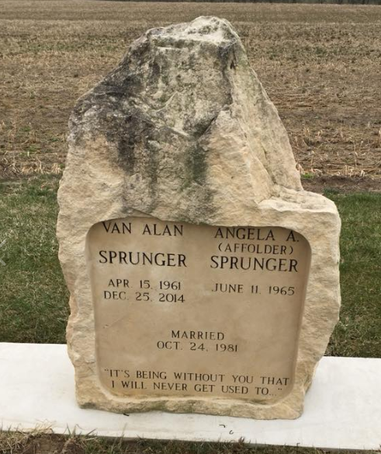
Photo by Scott Shoup

Van A. Sprunger, 53, Bryant, passed away on December 25, 2014 at his residence. He was born to Earl H. and Marinel Striker Sprunger on April 15, 1961 in Adams County. He married Angie Affolder on October 24, 1981.
Van was employed at Meshberger Bros. as maintenance supervisor for 21 years. He attended the West Missionary Church and was a former member of the Berne Fire Department for 11 years. His interests included; hunting, the outdoors, classic cars and he loved his family and grandchildren.
Survivors include; his parents, wife, Angie, a son, Daniel (Heidi) Sprunger of Berne, daughter, Denise (James) Sprunger of Berne, sisters; Gail (Don) Kuhn of Berne, Dana (Gerald) Zuercher Schwartz of Berne, Kenya (Rod) Habegger of Berne and 5 grandchildren, Brendon, Colton, Alena, Dakota, and Brock Sprunger.
Funeral services are Monday, December 29, 2014 at 2:00 p.m. at the West Missionary Church with visitation 1 hour prior to services. Visitation also Sunday, December 28, from 1-8 p.m. at the funeral home. Officiating is Pastor Keith Rupp. Burial is in the MRE Cemetery, Berne.
Preferred memorials are to C & C Fellowship &/or Adams County Foundation-Cancer Fund. Sign guest book at yagerkirchhofer.com

Zwick & Jahn Funeral Homes, Adams County, Indiana

