Ulrich Sprunger
January 7, 1860 – March 4, 1932

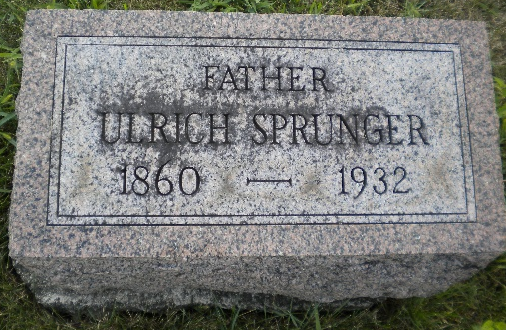
Photo by DSON1492

Indiana, U.S., Death Certificates, 1899-2017

Name Ulrick Sprunger (indexed as Springer)
Gender Male
Race White
Marital Status Married
Age 72y 26d
Birth Date 7 Jan 1860
Birth Place Indiana
Death Date 4 Mar 1932
Death Place Berne, Adams, Indiana, USA
Death Registration Date 1932
Father Christian Springer b. Switzerland
Mother Mary Ann Lehman b. Switzerland
Spouse Anna Springer
Informant Eldon E. Sprunger, Berne, IN
Burial M.R.E. 3/7/1932
**

U.S., Family History Books

Name Ulrich Sprunger
Gender Male
Birth Date 7 Jan 1860
Birth Place Adams County, Indiana
Spouse Anna Liechty
Child Theodora, Walter
Title The Sprunger Family, 1757-1972: in Three Parts From Manuscripts
Author Lochner, Electa I. Baltzell (Electa Iantha Baltzell), 1895- , p. 55
21. Ulrich Sprunger, born January 7, 1860 in Adams County, Indiana, married Anna Liechty, daughter of Jacob Lichty. They lived on a farm in Adams County, Indiana.

