Tamae (Imasaka) Sprunger
September 23, 1941 – September 14, 2011

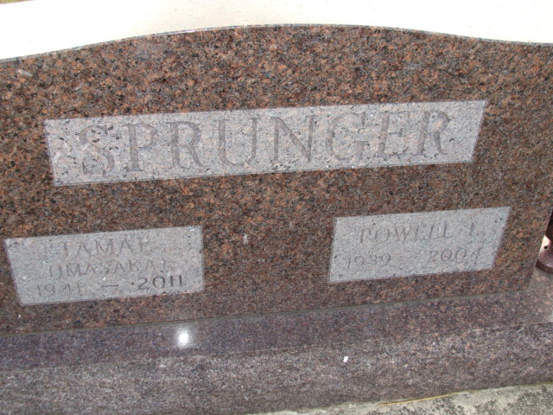
Photo by Alicia Kneuss

Tamae Sprunger, 69, Celina, Ohio, passed away September 14, 2011 in Van Wert, Ohio. She was born to Tamahe and Sasao Yamaguchiken in Yamaguchiken, Japan, both deceased. She married Powell Sprunger who is deceased.
Survivors include a son, Rene (Ange) Sprunger, North Bradford, Connecticut and a granddaughter, Kai Sprunger.
She graduated with a fashion design degree and a graduate from The American Academy of AHS-Chicago.
Private graveside services were held at the MRE Cemetery in Berne, Indiana on September 17, 2011.

Zwick & Jahn Funeral Home, Adams County, Indiana
**

Tamae Sprunger, 69, Celina, died Sept. 14, 2011, in the Hospice Center, Van Wert. She was born Sept. 23, 1941, in Shimonoseki, Yamaguchiken, Japan, to Tamahe and Sasao Furuya Imasaka. She married Powell Sprunger, who died in 2004.
Surviving are a son, Rene (Ange) Sprunger, North Branford, Conn., and a granddaughter.
She held a two-year degree in fashion design and was a graduate of the American Academy of Arts, Chicago.
Private graveside services were held Sept. 17, 2011, at MRE Cemetery, Berne, Ind.
Arrangements were handled by Yager Kirchhofer Funeral Home, Berne.

The Daily Standard, Celina, Ohio
Friday, September 23, 2011

