Sybilla G. Sprunger
July 10, 1897 – February 4, 1966

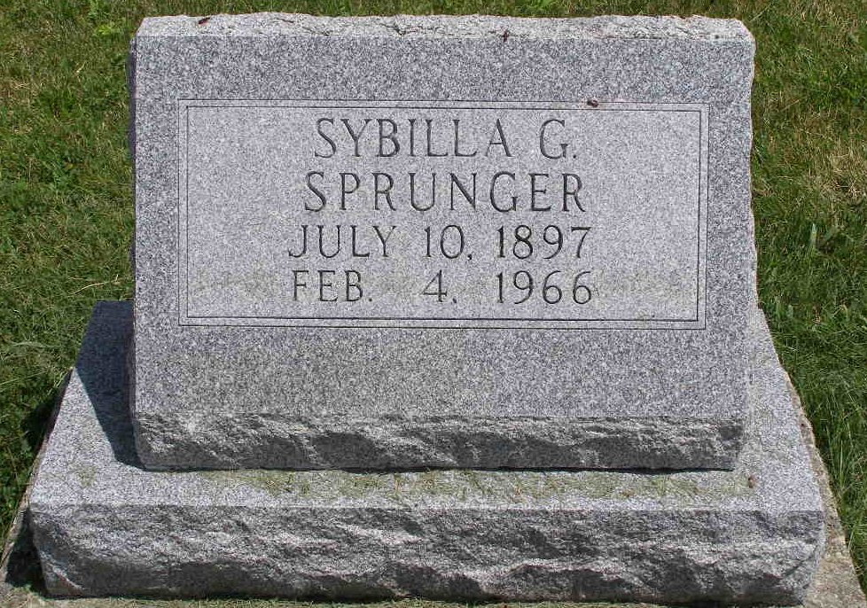
Photo by Shaunda Bedwell Opdycke

Miss Sybilla G. Sprunger, 69, a retired high school teacher, passed away at 3:55 0’clock this morning at the Adams County Memorial hospital, where she had been a patient since Christmas eve. Her death came suddenly and unexpectedly. Miss Sprunger suffered a paralytic stroke on the evening before Christmas and has been convalescing at the hospital since that time. She was rendered helpless by the stroke and was also unable to communicate during this time.
The deceased devoted her life to high school teaching. She attended Bluffton college and was graduated from Indiana university and later did graduate work there. She also had a degree in library science. Miss Sprunger taught high school in Monroe, Elkhart, Hartford and Jefferson townships in Adams county and at Leo. At the latter place she also served as librarian in addition to her teaching assignments.
Miss Sprunger operated the Sprunger Music Store in her home for quite a number of years, where through the years she taught piano to many local young musicians. Miss Sprunger was a faithful member of the First Mennonite church where for many years she served as one of the church organists, also as a Sunday School teacher. The deceased was obliged to discontinue her school work in October 1962, when she suffered her first stroke. After many weeks in the hospital she was able to return to her home at 523 W. Water street, where she had resided since.
Her mother, Rosina Sprunger preceded her in death a number of years ago. There are no survivors, other than cousins and her many friends. Friends may call at the Yager Funeral Home after 3 o’clock Saturday afternoon. Services will be held there on Sunday afternoon at 3 o’clock with Rev. Gordon J. Neuenschwander officiating. Burial will be in M.R.E. cemetery.

Date of burial 06 Feb 1966.

Heritage Room, Berne Public Library, Berne, Indiana
MRE Cemetery Obituary Notebook – 1966-1972

