Susanna (Riesen) Sprunger
November 4, 1866 – December 30, 1951

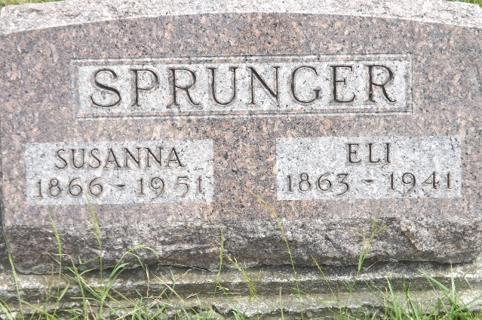
Photo by Jim Allen

Indiana, U.S., Death Certificates, 1899-2017

Name Susan Sprunger (indexed as Springer)
[Susan Riesen]
Gender Female
Race White
Marital Status Widowed
Age 85
Birth Date 4 Nov 1866
Birth Place Adams County, Indiana
Death Date 30 Dec 1951
Death Place Bluffton, Wells, Indiana, USA
Death Registration Date 1951
Father Samuel Riesen
Mother Barbara Lora
Informant Mrs. Th??? Stem
Burial 1-1-1952 M.R.E.
**

Indiana, U.S., Marriages, 1810-2001

Name Susannah Rieson
Gender Female
Event Type Marriage Registration (Marriage)
Marriage Date 2 Nov 1888
Marriage Place Indiana, United States
Spouse Eli Sprunger
Page 68
FHL Film Number 002321471

