Susanna H. (Inniger) Sprunger
March 9, 1902 – April 4, 1985

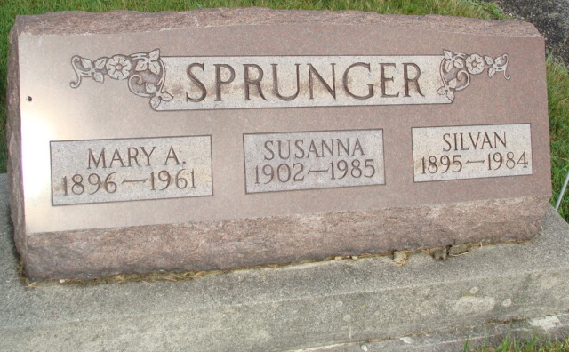
Photo by Alicia Kneuss

Indiana, U.S., Death Certificates, 1899-2017

Name Susan H Sprunger
[Susan H Inniger]
Gender Female
Race White
Marital Status Widowed
Age 83
Birth Date 9 Mar 1902
Birth Place Indiana
Death Date 4 Apr 1985
Death Place Berne, Adams, Indiana, USA
Death Registration Date 1985
Father Abraham Inniger
Mother Sarah Schwartz
Informant Mrs. Rosella Viers, sister
Burial M.R.E. 4/6/1985
**

Indiana, U.S., Marriage Certificates, 1960-2012

Name Susan Inniger
Gender Female
Race White
Marriage Age 44
Birth Date 9 Mar 1902
Birth Place Adams
Marriage License Date 13 Jun 1946
Marriage Date 16 Jun 1946
Marriage Place Adams, Indiana, USA
Residence Place Berne, Indiana
Spouse Jacob Haggard

