Steven S. Sprunger
February 23, 1939 – September 10, 2014

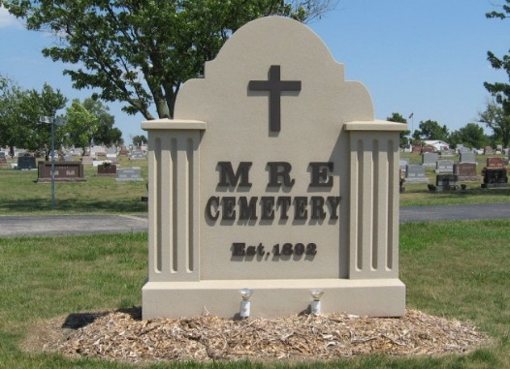
Photo by Tombstoner & Family

Steven S. Sprunger, 75, Berne passed away Wednesday, September 10, 2014 at Chalet Village, Berne. He was born to Herman and Arminda (Hirschy) Sprunger on February 23, 1939 in Adams County.
He was a member of the Mt Hope Church rural Berne and was formerly employed at Habegger Builders, Liechty Foods, and Home Dairy. His special interest centered around his grandchildren and he enjoyed gardening and antique cars.
Survivors include; three sons; Carl D. Sprunger of Pennville, Daniel J. Sprunger of Stuart, Fla. Steven (Stephenie) Sprunger of Berne, sister Jane Mann of Berne and 5 grandchildren.
Preceding in death are brothers Dwight, Berwyn, Lynn and Donavon Sprunger, & sister, Enid Sprunger
Funeral services are Monday, September 15, 2014 at 10:30 am at the Yager-Kirchhofer Funeral Home with visitation 1 hour prior to services. Visitation also Sunday from 3 to 8 pm at the funeral home. Officiating is Pastor Larry Eads. Burial is in the MRE Cemetery, Berne.
Preferred memorials are to the Family.
Yager-Kirchhofer Funeral Home, Adams County, Indiana
September 11, 2014

