Stanley Keith Sprunger
March 11, 1932 – March 11, 1932

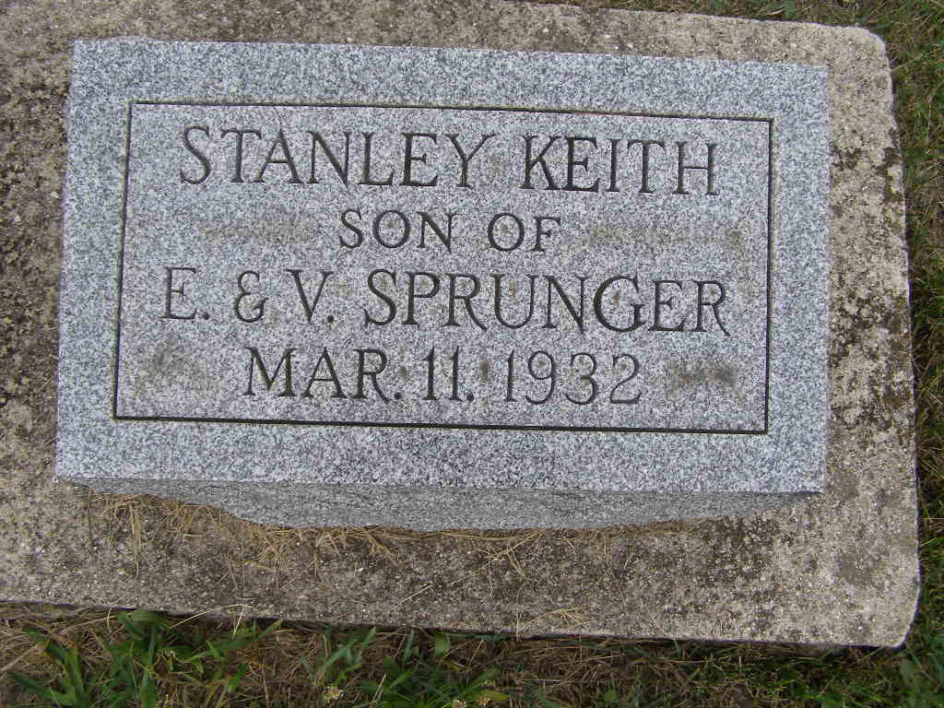
Photo by Shaunda Bedwell Opdycke

U.S., Family History Books

Name Stanley K Sprunger
Birth Date 11 Mar 1931
Birth Place Adams Co., Indiana
Father Edison Sprunger
Mother Viola Schlatter
Title The Descendants of Peter Neuhauser, 1802-1862, p. 27
Author Neuhauser, M. D.
8. Viola Schlatter, b. 3/11/1904 in Allen Co., Indiana
married Edison Sprunger on 8/7/1927
Edison Sprunger b. 11/11/1899 in Adams Co, IN d. 7/11/1942
a. Stanley K Sprunger b. 3/11/1931 in Adams Co, Indiana. Still born.
b. Kenyon L. Sprunger b. 11/25/1933 in Adams Co, Indiana
c. Benjamin E. Sprunger b. 8/27/1937 in Adams Co, Indiana
Viola married Palmer Moser on 8/12/1955.
Palmer Moser b. 5/5/1901 in Adams Co., IN d. 4/6/1972

