Stanley K. Sprunger
May 4, 1934 – January 13, 2015

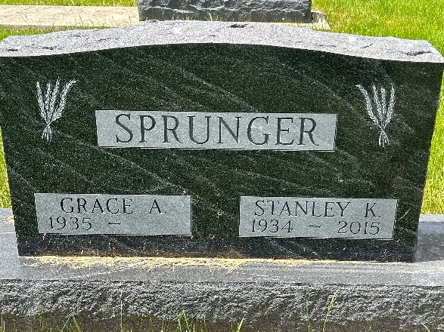
Photo by Barbara Baker Anderson

Stanley K. Sprunger, 80, Berne, passed away Tuesday, January 13, 2015 at Select Specialty Hospital in Fort Wayne due to complications following surgery. He was born on May 4, 1934 in Berne. He was married to Grace (Baumgartner) Sprunger on September 8, 1956.
He was a graduate of Adams Central High School in 1952. He was a member of the First Mennonite Church of Berne where he served as an usher for many years and helped with kindergarten Sunday School for 22 years. Stan was a dairy farmer for 44 years until ill health prevented him from actively farming. After that, he enjoyed providing transportation to many friends and coworkers. He also enjoyed spending time with his grandchildren.
He is survived by his wife, Grace, of Berne and three children: Cindy (Tim) Moore of Indianapolis, Cathy Sprunger of Indianapolis, and Curt (Lori) Sprunger of Berne; five grandchildren: Chris (Katie) Moore of Indianapolis, Molly Moore of Indianapolis, Maggie Moore of West LaFayette, Keith Sprunger of Berne, and Kyle Sprunger of Berne. One great-grandchild, Samuel Moore of Indianapolis. He is also survived by sisters, Helen Buckingham, Kathryn Sprunger, and Marjorie Gaskill.
He was preceded in death by his parents, Noah and Amelia Sprunger, and brothers; Roger W. Sprunger and Rev. Adrian Sprunger.
Visitation will be from 2:00 - 8:00 p.m. on Friday, January 16, 2015 at Yager-Kirchhofer Funeral Home in Berne and at the church one hour prior to the service. The funeral service will be Saturday, January 17, 2015 at 10:30 a.m. at the First Mennonite Church with Rev Jerry A.Flueckiger officiating. Burial is in the M.R.E. Cemetery, Berne.
Memorials may be made to First Mennonite Church Missions &/or the MCC Meat Canner Project.

Yager-Kirchhofer Funeral Home, Adams County, Indiana
February 25, 2015

