Simeon Sprunger
February 2, 1859 – July 10, 1941

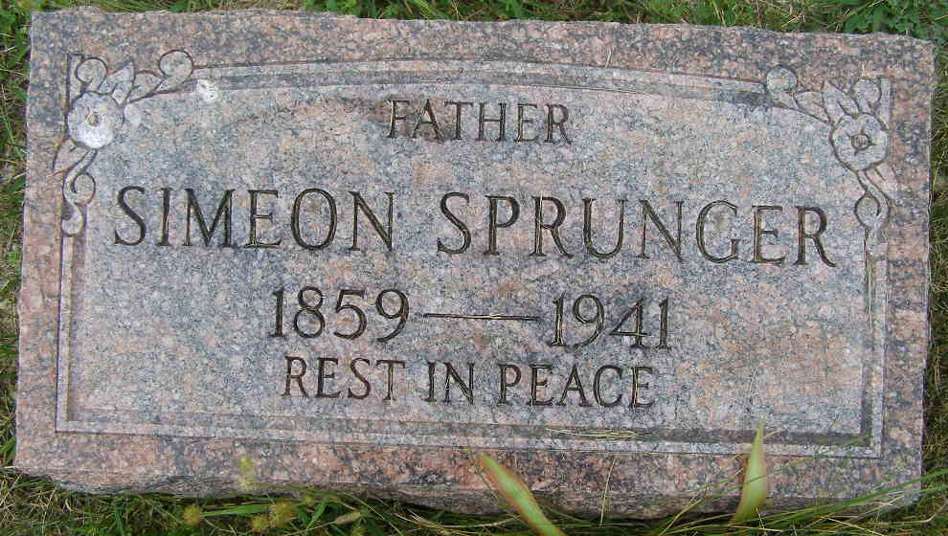
Photo by Shaunda Bedwell Opdycke

ADAMS COUNTY FARMER DIES
Simon Sprunger Dies Suddenly This Morning At Home In Berne
Simon Sprunger, 82, retired farmer, died suddenly this morning at 5:15 o'clock at his home in Berne. Death was attributed to heart trouble and was unexpected, although he had been ailing for some time.
He was born in Wayne county, Ohio on February 2, 1859, the son of Abraham and Catherine Sprunger. He was married twice, first to Emma Huser and later to Rachel Sprunger. Both are deceased. He moved to Berne from his farm in Monroe township in 1929. He was a member of the Mennonite church.
Surviving are eight sons; Emil of Berne, Philemon of Chicago, Jacob and Menno of Berne, Martin of Decatur, Simon of Walkerton, Albert of Monticello and Gerhart of Berne; six daughters; Delphine of Los Angeles, Mrs. Helen Hirschy of Berne, Elvira at home, Mrs. William Burry of Geneva, Selma and Emma both of Los Angeles; 45 grandchildren and seven great-grandchildren.
Funeral services will be held Saturday afternoon at 1:30 o'clock at the home and 2 o'clock at the Berne Mennonite church, of which he was a member. Burial will be in the M.R.E. cemetery.
Adams County, Indiana Historical Museum
Scrapbook 1941b
Handwritten-July 10, 1941
**
SIMON SPRUNGER, RETIRED FARMER, DIES THURSDAY
Funeral for Aged Man is at Mennonite Church Saturday P.M.
Simon Sprunger, age 82, retired farmer residing on East Water Street for many years, died unexpectedly at 5:15 Thursday morning at his home here. Death was caused from heart trouble from which he had been ailing for some time. He had been ill two days and he suffered from spasmodic asthma.
Mr. Sprunger was converted and baptized in his youth and remained a faithful member of the First Mennonite Church here where the final rites will be conducted at 2:00 p.m. Saturday following a short service at the home at 1:30. Dr. C. H. Suckau, pastor of the church, will officiate and interment will be in the M.R. E. Cemetery west of town.
The decedent some years ago began a hobby of keeping records of the older residents of the community, especially those belonging to the Mennonite Church and had gathered considerable data.
Mr. Sprunger was born February 1, 1859 in Wayne County, O., the son of Abraham and Katherine Zingg Sprunger. He came to Berne with his parents at the age of two years and resided here since that time. He moved to Berne from his farm in Monroe Township in 1929.
While a young man he taught a Sunday school class. He was said to be the oldest Sprunger living up to the time of his death.
On October 10, 1880 he was married to Emma Huser. To this union eight children were born. His wife died October 2, 1893. Later, on March 18, 1894, he was married to Rachel R. Sprunger who died in 1926. To this union eight children were born.
Surviving are eight sons: Emil of Berne, Philemon of Chicago, Jacob and Menno of Berne, Martin of Decatur, Simon of Walkerton, Albert of Monticello and Gerhart of Berne; six daughters, Delphine of Los Angeles, Mrs. Martha Hirschy of Berne, Elvina at home, Mrs. William Burry of Geneva, Selma and Emma both of Los Angeles; 45 grand-children and seven great-grandchildren. A half-sister, Mrs. Louis Habegger of this place, also survives.
His two wives, a son in infancy and a daughter, Matilda, preceded.
Adams County, Indiana Historical Museum
1941Aug-Oct Scrapbook, Image 96
Handwritten-Fri. July 11, 1941
**
Indiana, U.S., Death Certificates, 1899-2011
Name: Simon Sprunger
Gender: Male
Race: White
Age: 82 years, 5 months, 8 days
Marital status: Widowed
Birth Date: 2 Feb 1869 [sic - 1859]
Birth Place: Wayne Co Ohio
Death Date: 10 Jul 1941
Death Place: Berne, Adams, Indiana, USA
Death Registration Date: 1941
Father: Abraham Sprunger
Mother: Catherine Zing
Spouse: 1st: Emma Huser; 2nd: Rachel Sprunger; deceased
Informant: Emil Sprunger; Berne, Indiana
Burial: July 12, 1941; MRE Cemetery; Berne, Indiana

