Silvan Sprunger
April 27, 1895 – January 17, 1984

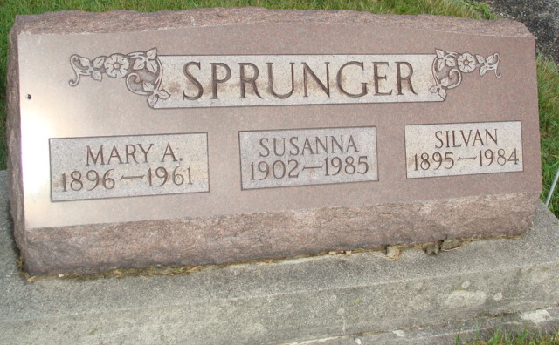
Photo by Alicia Kneuss

Indiana, U.S., Death Certificates, 1899-2017

Name Silvan Sprunger
Gender Male
Race White
Marital Status Married
Age 88
Military WW I
Birth Date 27 Apr 1895
Birth Place Indiana
Death Date 17 Jan 1984
Death Place Decatur, Adams, Indiana, USA
Death Registration Date 1984
Father Emmanuel Sprunger
Mother Katherine Stauffer
Spouse Susan Sprunger, informant
Burial M.R.E. 1/20/1984

