Silas Sprunger
October 10, 1868 – March 1, 1960

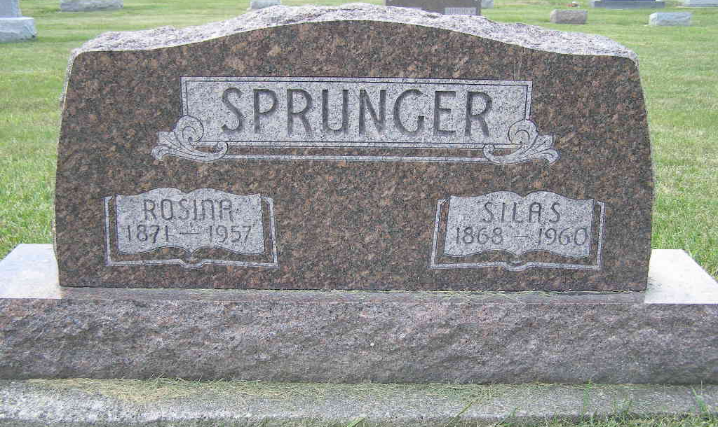
Photo by Shaunda Bedwell Opdycke

Silas Sprunger Dies Early This Morning
Silas Sprunger, 91, a resident of Berne most of his life, died at 4 o'clock this morning at the home of a daughter, Mrs. Lawrence Von Gunten, southeast of Decatur. He had been bedfast for two years, and for the last three weeks had been at his daughter's home.
He was born in Berne Oct. 10, 1868, a son of Jacob and Anna Sprunger. His wife, the former Rosina Riff, died three years ago. Mr. Sprunger was a cabinet maker and clock repairman, and also had served as an assessor in Wabash and Monroe Townships and at Fort Wayne.
Surviving are three sons, Hubert Sprunger of Winter Haven, Fla.; Milo Sprunger of Pendleton, and Fenton Sprunger of Monroe; three daughters, Mrs. A.F. Dailey of Decatur, Mrs. Franklin Von Gunten of Fort Wayne, and Mrs. Lawrence Von Gunten of southeast of Decatur; 12 grandchildren; 10 great-grandchildren; two brothers, Nathan Sprunger of Berne, and Cornelius Sprunger of Orville, O., and one sister, Mrs. James Powers of Lafayette. One son is deceased and two children died in infancy.
Funeral services will be conducted at 10 a.m. Friday at the First Mennonite Church in Berne, the Rev. Gordon Neuenschwander officiating. Burial will be in MRE Cemetery. The body ws removed to the Yager Funeral Home at Berne, where friends may call after 7 o'clock Wednesday evening until time of the services.
Adams County, Indiana Historical Museum
Jan1958-Dec1960 Scrapbook, Image 32
Handwritten-Tues. March 1, 1960

