Shirley A. (Schug) Sprunger
April 20, 1925 – November 29, 1986

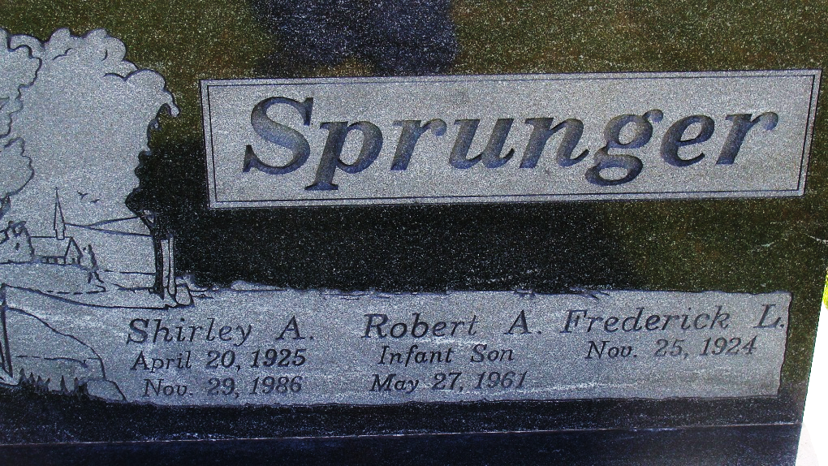
Photo by Alicia Kneuss

SHIRLEY A. SPRUNGER

Shirley A. Sprunger, 61, 2119 Riverside Dr., Huntington, died at 2:10 a.m. Saturday, November 29, at home. Born on April 20, 1925 in Berne, she was the daughter of Walter and Lenora (Yoss) Schug. She married Frederick Sprunger on January 16, 1948 and he survives. Also surviving are two sons, Fritz of Huntington and James of Fort Wayne; one daughter, Jacquie Hartman of Albany; her stepmother, Dee Schug of Fort Wayne; two brothers, Jack and Paul Schug both of Huntington; one sister, Alice Stevens of Cedar Rapids, Iowa; and six grandchild-ren.
Services were held at 2:00 p.m. today at the First Church of the Nazarene on Flaxmill Rd. in Huntington, with Rev. Robert Smith, Rev. Gary Koch, and Rev. Virgil Sprunger officiating. Burial is in the MRE Cemetery. Memorials are to the First Church of the Nazarene in Huntington. Arrangements by Deal & Robbins Funeral Home.

Berne Witness, Adams County, Indiana
Monday, Dec. 1, 1986

