Sherwood S. Sprunger Jr.
September 12, 1951 – March 22, 1964

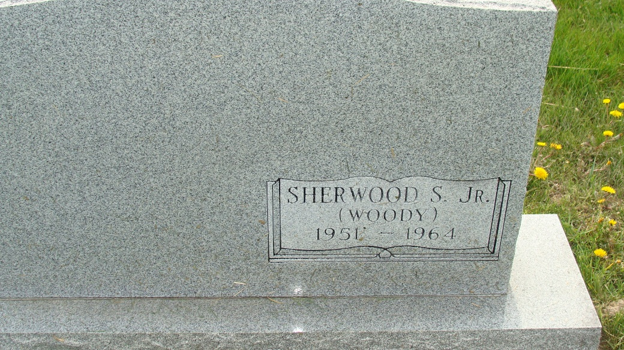
Photo by Alicia Kneuss
Assuming this is the back of his parents, Sherwood & Dorothy Ball Sprunger’s tombstone

Indiana, U.S., Death Certificates, 1899-2017

Name Sherwood S Sprunger Jr
Gender Male
Race White
Marital Status Never Married (Single)
Age 12
Cause of death cardiac arrest (Hurler's Syndrome)
Birth Date 12 Sep 1951
Birth Place Indiana
Death Date 22 Mar 1964
Death Place Fort Wayne, Allen, Indiana, USA
Death Registration Date 1964
Father Sherwood S Sprunger Sr., informant
Mother Dorothy Ball
Burial 3/24/1964 Greenlawn Memorial Park, Ft. Wayne, IN

