Sherwood S. Sprunger
August 22, 1919 – July 6, 2007

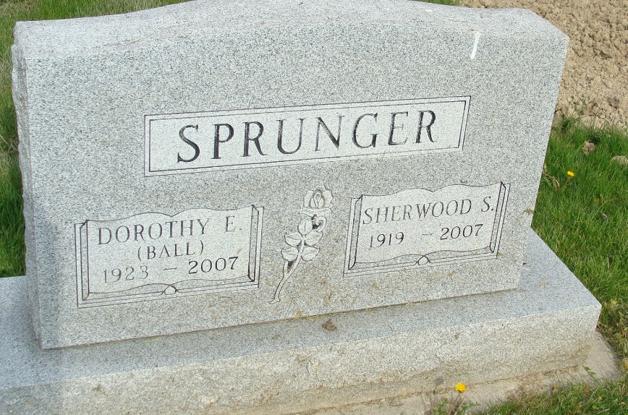
Photo by Alicia Kneuss

Sherwood S. Sprunger, 87 years old of Tallahassee, Florida, passed away at his residence on July 6, 2007. Sherwood was born on August 22, 1919 in Berne, Indiana, the son of the late Theodore Sprunger and the late Rosina (Nussbaum) Sprunger. He married Dorothy Ball on February 4, 1945 in Washington D.C. and she survives. Sherwood was a member of the First Mennonite Church in Berne, Indiana and had been a United States Mail Handler.
Sherwood is survived by his wife, Dorothy Sprunger of Tallahassee, Florida; daughter, Susan (Charles) Vodicka of Miami, Florida; daughter, Sandra (Dennis) Howard of Tallahassee, Florida; son, Wendell Sprunger of Los Angeles, California; sister, Verena (Gordon) Sprunger of Berne, Indiana; and two grandchildren: Sarah and Georgia Howard of Tallahassee, Florida. Sherwood was preceded in death by a son, Sherwood S. Sprunger, Jr. in 1964; and two brothers, Willard and Marian Sprunger.
Graveside Services will be held at 10:00 a.m. Friday, July 20, 2007 at the M.R.E. Cemetery in rural Berne, Indiana.
Yager-Kirchhofer Funeral Home, Adams County, Indiana

