Sherman Ted Sprunger
September 12, 1877 – October 14, 1928

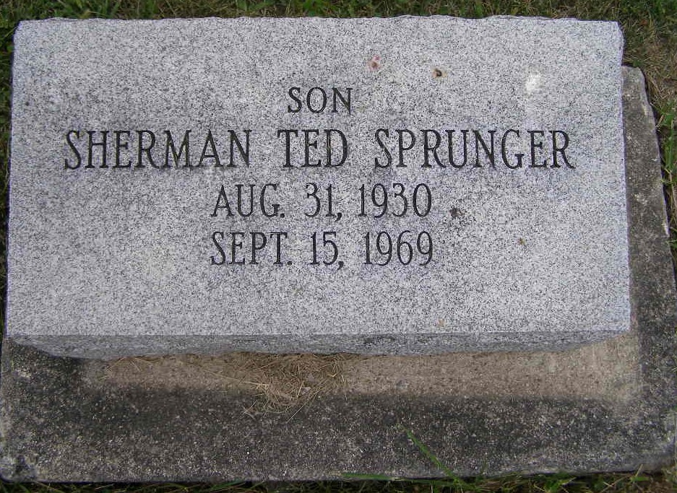
Photo by Shaunda Bedwell Opdycke

Sherman Ted Sprunger Dies This Morning

Sherman Ted Sprunger, 39, of Wabash Township, an employee of CTS of Berne, Inc., died at 3 am today at the Jay County Hospital in Portland, where he had been a patient since Saturday. Mr. Sprunger resided with his parents, Mr. and Mrs. Irvin T. Sprunger in Wabash Township, west of Geneva.
He had been afflicted with a kidney disease and recently spent several weeks in the Robert Long Hospital in Indianapolis. He returned to his home after his condition improved and he returned to work at CTS. He worked last Monday, then had to quit when he became ill again. The immediate cause of death was pneumonia. He was employed at CTS the last seven years and prior to that worked at Dunbar Furniture Company for a number of years.
He was born in Wabash Township August 31, 1930, a son of Irvin T. and Lillian Yoss Sprunger.
Surviving are the parents and a sister, Mrs. Lawrence (Julia) McCullough of Monroe. A sister, Christine, preceded in death.
Mr. Sprunger was a member of the First Missionary Church in Berne. The funeral will be held at 10 am Wednesday at the First Missionary Church, Rev. Gerald Gerig officiating. Burial will be in the MRE Cemetery. The body will lie in state at the church from 9 am to 10 am Wednesday.
The body is at the Hardy and Hardy Funeral Home in Geneva, where friends may call after 4 pm Tuesday.

Date of Death: September 15, 1969; Date of Burial: September 17, 1969
Burial: Lot 452, Original Platt

Berne Library (IN) Heritage Room
MRE Obits 1969-1972

