Sanford Sprunger
November 13, 1913 – November 13, 1913

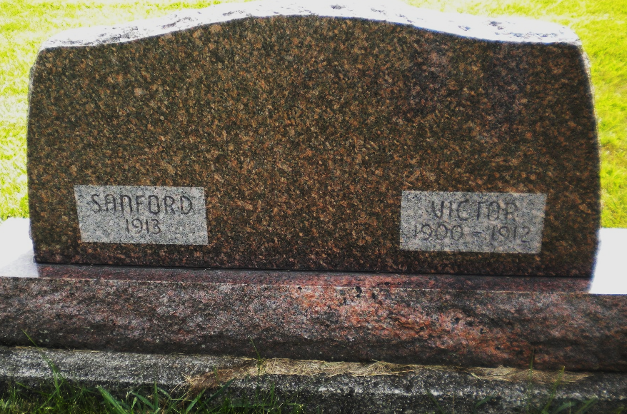
Photo by DSON1492
On back of parents Silas and Rosina Sprunger’s tomb

Indiana, U.S., Death Certificates, 1899-2017

Name Sanford Sprunger
Gender Male
Race White
Age 0
Cause of death Cerebral apoplexy
Birth Date 13 Nov 1913
Birth Place Adams, Co.
Death Date 13 Nov 1913
Death Place Wabash, Adams, Indiana, USA
Death Registration Date 1913
Father Silas Sprunger, informant
Mother Rosina Reef
Burial MRE 11/14/1913

