Sandra Kay Sprunger
June 21, 1940 – June 21, 1940

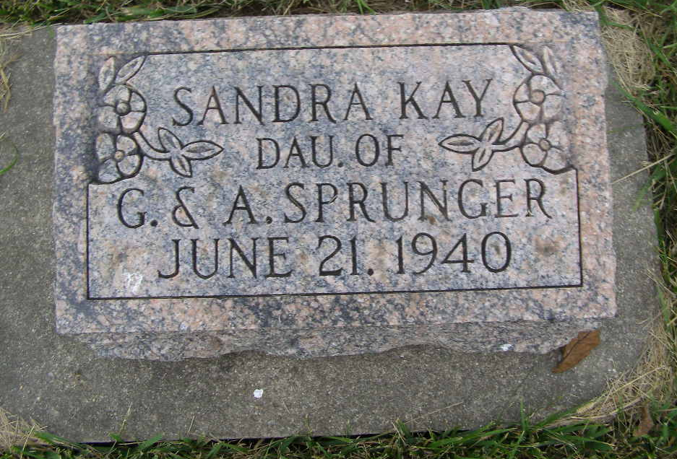
Photo by Shaunda Bedwell Opdycke

Indiana, U.S., Death Certificates, 1899-2017

Name Sandra Key Springer
[Sandra Kay Sprunger]
Gender Female
Race White
Age 15 minutes
Cause of death premature birth
Birth Date 21 Jun 1940
Birth Place Bluffton, Wells, Indiana
Death Date 21 Jun 1940
Death Place Bluffton, Wells, Indiana, USA
Death Registration Date 1940
Father Gerhart Sprunger, informant
Mother Alta Raber
Burial M.R.E. 6/22/1940

