Rev. Samuel F. Sprunger
October 19, 1848 – November 16, 1923

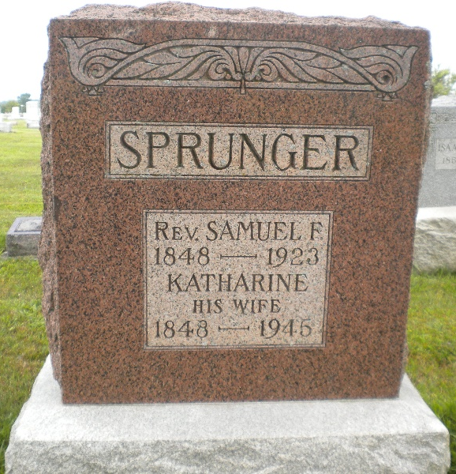
Photo by DSON1492

PORTLAND – The Rev. Samuel Sprunger, 85 years old, native of Switzerland and ex-pastor of the Mennonite church at Berne for a period of thirty-three years, died at his home Friday after a long illness. Pneumonia was the direct cause of death. The Rev. Mr. Sprunger was the father of Editor B. F. Sprunger of this city and had been a resident of Berne since 1852. Besides his wife he leaves ten children.

Unknown newspaper clipping
**

On 23 Aug 1868 S.F. SPRUNGER, then just 19 years old, became the minister of the Berne [First Mennonite] Church. Before taking up his duties, he took 2 ½ years of training at Wadsworth Seminary in Ohio. He was in the first graduating class of 1871, and subsequently began his long ministry in Berne. He was ordained Elder 5 Mar 1874. By 1879, the congregation had outgrown its first building and a new meeting-house was built. After the 1879 building was in use, the old church was taken down and David Sprunger built horse sheds where the farmers could hitch their horses and buggies. Barely seven years later, the church again proved too small and an addition was attached to the building, making the church T-shaped. Two more balconies were added, as well as a much needed nursery for mothers and babies. Church growth continued to be rapid under the strong leadership of S.F. Sprunger and in 1899; the building was further enlarged, adding seating for 255 people. It was this time that the bell was added, which still calls worshipers to the church. Samuel initiated quite a few changes within the church and is viewed as an outstanding leader.
His family was the second Mennonite family to own a reed organ. It was this organ that was most likely taken to the church for use on special occasions prior to the church having one installed. He attended the first seminary established by Mennonites in America. He led the church as it moved out of its restrictive isolation into a more vibrant form of faith expression. He supported the new developing General Conference Mennonite Church and represented the congregation at early meetings. Support of mission endeavors was initiated, along with programs that enhanced the life of the local congregation such as Christian education.
Health problems brought on the resignation of S.F. Sprunger in 1903. He had been the pastor and leader since 1871. Under his pastorate, the Sunday School had become a strong arm of the church; the choral society was started and presented its first oratorio, Hayden's Creation, in 1890; the Women's Missionary Society was organized at his suggestion in 1887; the church records began to be kept and in the 1890s, year books were printed. He served on the Foreign Mission Board of the GC Mennonite Church from 1884 - 1887 and again from 1896 - 1917; on the Publication Board from 1884 - 1893, and the Home Mission Board for many years. He edited the German Sunday school quarterly from 1889 - 1920 and the Bundesbote Kalender from 1886 - 1922. Sprunger served the Berne church as active pastor from 1871 - 1903, from 1911 - 1913, and as supply pastor 1914 - 1919. He preached his last sermon on Sept. 14, 1919.
Sprunger was not in good health the last 20 years of his life. He had an eye operation in 1902, and in 1903 he suffered from a fractured hip when he fell while chasing some chickens. He never fully recovered and had to use a cane. He died of pneumonia on November 16, 1923. Samuel and Mrs. Sprunger had ten children. (See also GC Mennonite Pioneers, 1973)

The Berne Tri-Weekly, Adams County, Indiana
23 Jul 2003
**

Indiana, U.S., Death Certificates, 1899-2017

Name Samuel F Springer
Gender Male
Race White
Marital Status Married
Age 75y 0m 27d
Birth Date 19 Oct 1848
Birth Place Switzerland
Death Date 16 Nov 1923
Death Place Monroe, Adams, Indiana, USA
Death Registration Date 1923
Father Abraham Sprunger b. Switzerland
Mother Anna Reufenach
Spouse Kathrena Sprunger
Informant Mrs. Sara F. Sprunger
Burial MRE Cem. 11/18/1923

