Samuel A. Sprunger
November 21, 1868 – September 13, 1909

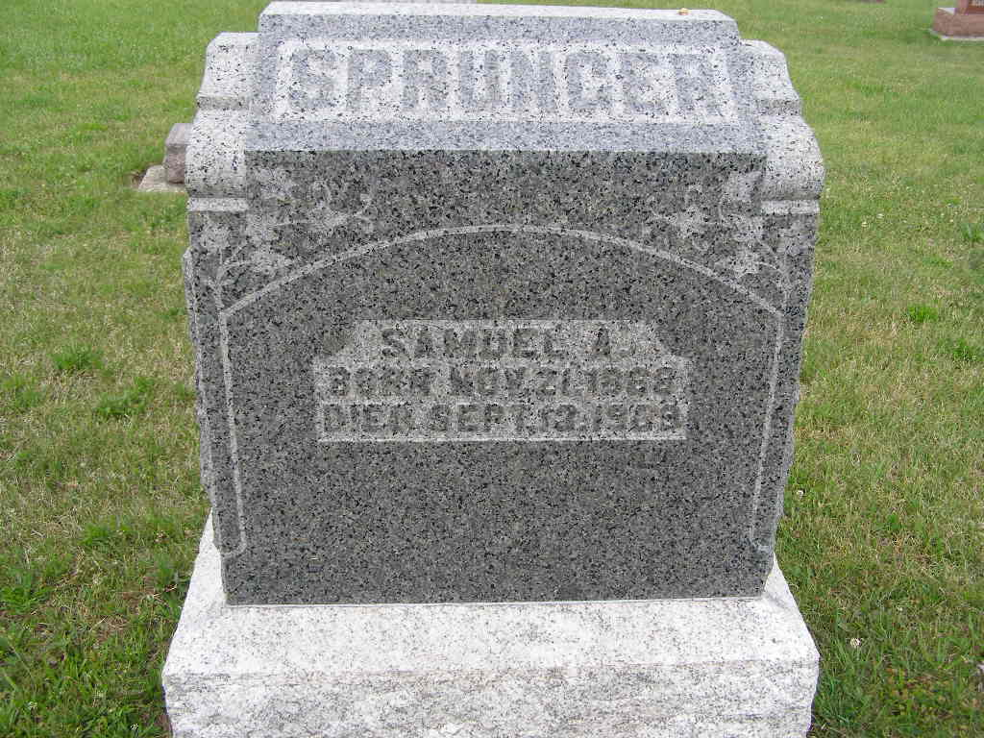
Photo by Shaunda Bedwell Opdycke

Indiana, U.S., Death Certificates, 1899-2017

Name Samuel A Sprunger (indexed as Springer)
Gender Male
Race White
Marital Status Married
Age 40y 9m 22d
Birth Date 21 Nov 1868
Birth Place Adams
Death Date 13 Sep 1909
Death Place Reme, Adams, Indiana, USA
Death Registration Date 1909
Father Abraham A Springer b. Europe
Mother Maria Luginbill b. Ohio
Spouse Goldie
Informant L A Sprunger, Berne, IN
Burial MRE 4/15/1909

