Salem Simeon Sprunger
April 17, 1891 – June 7, 1892

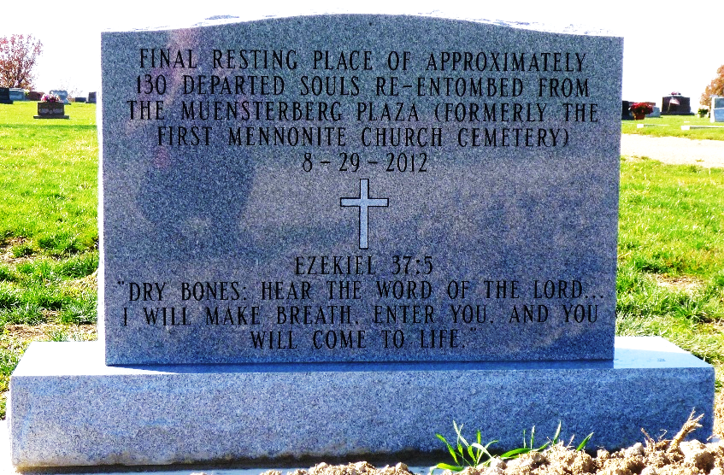
Photo by Max Haines

According to Max Haines, he was originally buried in the old Mennonite Cemetery, Berne, IN. and was moved to MRE Cemetery near Berne, IN in 2012. The above is the only grave marker.
**

Salem Sprunger from tree Julie Frederick Family Tree

Birth 17 Apr 1891 Berne, Adams, Indiana, USA
Death 7 Jun 1892 Berne, Adams, Indiana, USA
Father Johann A Sprunger (1852-1911)
Mother Katharina Sprunger (1859-1934)
14197 People 1 Record 4 Sources

