Shawn Jeff Sprunger
April 19, 1970 – June 26, 1989

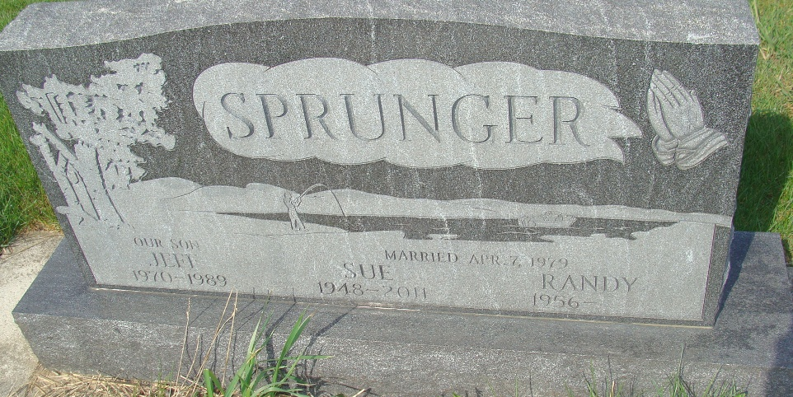
Photo by Alicia Kneuss

Indiana, U.S., Death Certificates, 1899-2017

Name Shawn Jeff Sprunger
Gender Male
Race White
Marital Status Never Married (Single)
Age 19
Birth Date 19 Apr 1970
Birth Place St. Louis, Missouri
Death Date 26 Jun 1989
Death Place Wells, Wells, Indiana, USA
Cause of death single vehicle auto accident, drowning
Death Registration Date 1989
Father Randy L. Sprunger,informant
Mother Sue (Griffin) Sprunger
Burial 6/29/1989 M.R.E. Cemetery

