Ruth E. (Montgomery) Sprunger
August 27, 1922 – October 19, 2002

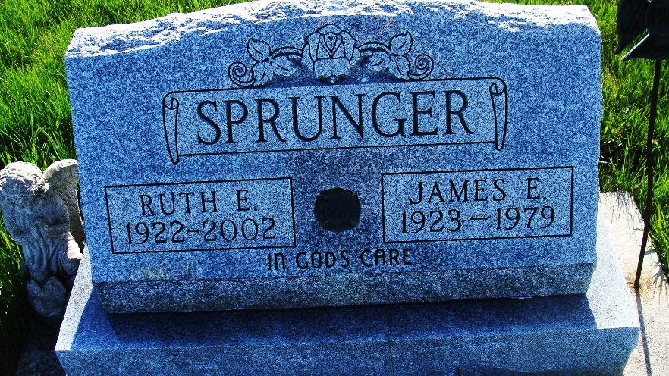
Photo by Alicia Kneuss

Ruth E. Sprunger, 80, of Berne, who liked crocheting, died Saturday, Oct. 19, 2002, at Adams County Memorial Hospital. The Jay County native was a member of the First Mennonite Church and had worked at Smith Brothers.
Surviving are a son, James of Berne; daughters Becky Sprunger of Berne, and Julia Lafollette of South Bend; brothers F.M. Ted Montgomery of Portland, and Bill Montgomery of Wabash; a sister, Esther Resler of Berne; six grandchildren and five great-grandchildren. She was preceded in death by her husband, James E., and a brother.
Services are 10:30 a.m. Wednesday at First Mennonite Church, Berne, with calling one hour before services. Calling is also from 2 to 8 p.m. Tuesday at Yager-Kirchhofer Funeral Home, Berne. Burial will be at M.R.E. Cemetery, Berne. Memorials are to E.W.T.N. - Mother Angelica or to the church. Information provided by Yager-Kirchhofer Funeral Home, Berne.

News-Sentinel, The (Allen County, Indiana)
Monday, October 21, 2002

