Ruby (Schlagenhauf) Sprunger
October 31, 1902 – January 10, 1988

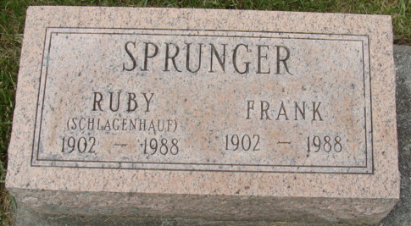
Photo by Alicia Kneuss

Indiana, U.S., Death Certificates, 1899-2017

Name Ruby Sprunger
[Ruby Schlagenhauf]
Gender Female
Race White
Marital Status Married
Age 85
Birth Date 30 Oct 1902
Birth Place Adams County, Indiana
Death Date 10 Jan 1988
Death Place Berne, Adams, Indiana, USA
Death Registration Date 1988
Father Edwin Schlagenhauf
Mother Luticia Liddy
Spouse Frank Sprunger
**

Ruby Schlagenhauf from tree Lewis / Hager Family Tree

Birth 30 Oct 1902 Adams, Indiana, USA
Residence 1 Apr 1940 Berne, Adams, Indiana, USA
Death 10 Jan 1988 Berne, Adams, Indiana, USA
Father Edwin Schlagenhauf (1878-1969)
Mother Luticia Liddy (1880-1952)
Spouse Franklin Sprunger (Born 1902)
16948 People 8 Records 8 Sources

