Rosina (Riff) Sprunger
March 29, 1871 – February 1, 1957

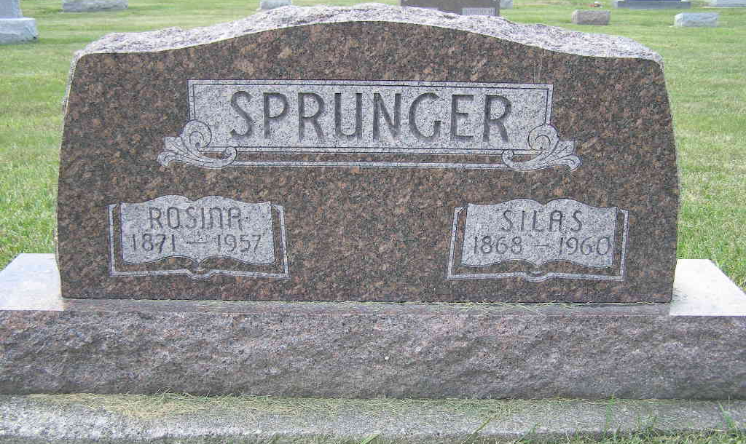
Photo by Shaunda Bedwell Opdycke

Mrs. Silas Sprunger Dies This Morning
Funeral Services Sunday Afternoon
Mrs. Silas Sprunger, 79, lifelong resident of Adams County, died at 4:15 o'clock this morning at the home of a daughter, Mrs. Lawrence Von Gunten, Decatur route 6. She had been in failing health for four years and bedfast since last Sunday.
She was born in Monroe Township March 29, 1877, a daughter of Samuel and Anna Speheger-Riss, and was married to Silas Sprunger, in Berne. Mr. and Mrs. Sprunger resided at the Von Gunten home.
Mrs. Sprunger was a member of the First Mennonite Church at Berne.
Surviving in addition to the husband are three son, Hubert Sprunger of Winter Haven, Fla., Milo Sprunger of Pendleton, and Fenton Sprunger of Monroe; three daughters, Mrs. Gus Dailey of Decatur, Mrs. Franklin Von Gunten of Fort Wayne, and Mrs. Lawrence Von Gunten of Decatur Route 6; 12 grandchildren and six great-grandchildren.
Funeral services will be conducted at 1:30 p.m. Sunday at the First Mennonite Church, the Rev. Olin A. Krehbiel officiating. Burial will be in the MRE Cemetery. The body was removed to the Yager Funeral Home at Berne, where friends may call after 1:30 p.m. Saturday until noon Sunday, after which it will lie in state at the church.
Adams County, Indiana Historical Museum
1955 Mar-April 1958 Scrapbook, Image 85
Handwritten-Fri. Feb. 1, 1957

