Rosina C. Sprunger
January 27, 1869 – October 15, 1941

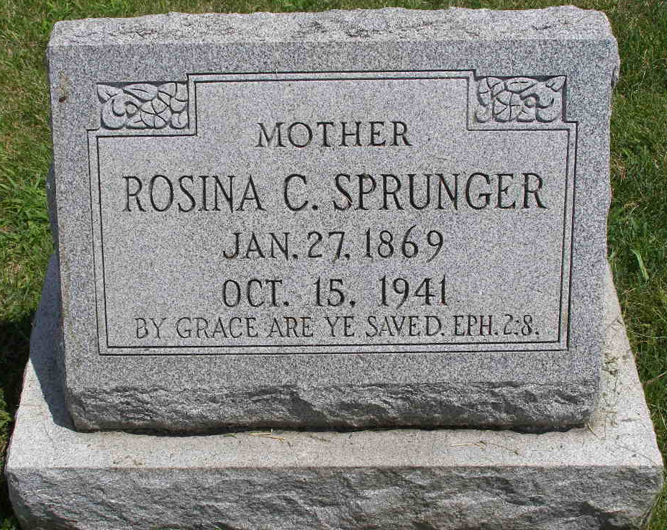
Photo by Shaunda Bedwell Opdycke

Indiana, U.S., Death Certificates, 1899-2017

Name Rosina C Sprunger
Gender Female
Race White
Marital Status Single
Age 72y 8m 18d
Birth Date 27 Jan 1868
Birth Place Berne Adams Co Indiana
Death Date 15 Oct 1941
Death Place Berne, Adams, Indiana, USA
Death Registration Date 1941
Father Christiane Sprunger b. Switzerland
Mother Mary Ann Lehman b. Switzerland
Informant Sybilla Sprunger, Berne, IN
Burial 10-17-1941 M.R.E.

