Rosina Sprunger
November 27, 1879 – April 21, 1923

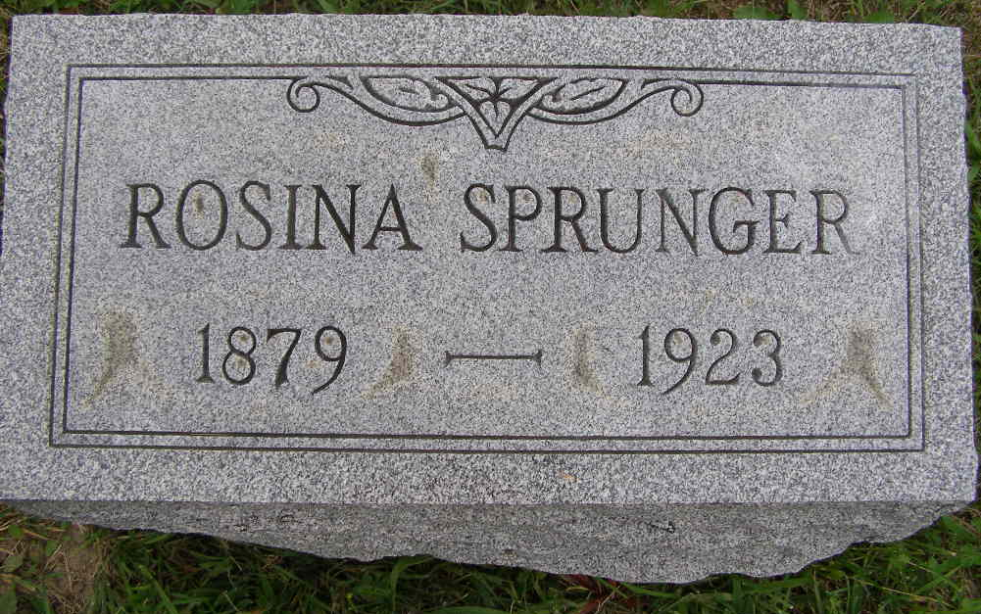
Photo by Shaunda Bedwell Opdycke

Miss Rosina Sprunger Died at Berne Saturday

Miss Rosina Sprunger, age 43 years, well known lady of Berne, died at the home of her mother, Mrs. P. A. Sprunger on Sprunger Street Saturday morning at 5:20 o'clock. Her death came after an illness of nearly ten weeks. The cause of her death was Graves' disease. During the ten weeks during which she had been sick she had been bedfast constantly, with the exception of one time when she was able to sit in a chair for a short time
Surviving the deceased are her mother, Mrs. P. A. Sprunger of Berne, and the following sisters and brothers: Mrs. Ben Flueckiger, Monroe Township; Mrs. David O. Lehman, Orrville, Ohio; Mrs. Armin Habegger, Monroe Township; Mrs. Elmer Luginbill, Miss Mildred Sprunger, William J. and Calvin Sprunger, all of Berne; Reuben, Jerry and Elmer Sprunger, all of Montana; Jonas Sprunger, of Monroe Township and Abr. P. Sprunger of Lima, Ohio.
Funeral services were held at the home at 1:30 this afternoon and at the Mennonite Church at 2 o'clock. Burial was made in the M.R.E. Cemetery.

Decatur Daily Democrat, Adams County, Indiana
Tuesday, April 24, 1923
**

Indiana, U.S., Death Certificates, 1899-2017

Name Rosina Sprunger (indexed as Springer)
Gender Female
Race White
Marital Status Single
Age 43 y 4m 24d
Birth Date 27 Nov 1879
Birth Place Adams County, Indiana
Death Date 21 Apr 1923
Death Place Monroe, Adams, Indiana, USA
Death Registration Date 1923
Father Peter A Sprunger b. Switzerland
Mother Katherine Sprunger b. Adams Co, IN
Informant Mrs. Peter A. Sprunger, Berne, IN
Burial MRE Cemetery 4/24/1923
**

Rosina Sprunger from tree Julie Frederick Family Tree

Birth 27 Nov 1879 Adams, Indiana, USA
Residence 1920 Adams, Indiana, USA
Death 21 Apr 1923 Berne, Adams, Indiana, USA
Father Dr. Peter A Sprunger (1839-1895)
Mother Katharina Sprunger (1853-1938)
14197 People 5 Records 20 Sources

