Rosemary K. (Hanni) Sprunger
November 24, 1927 – February 25, 2019

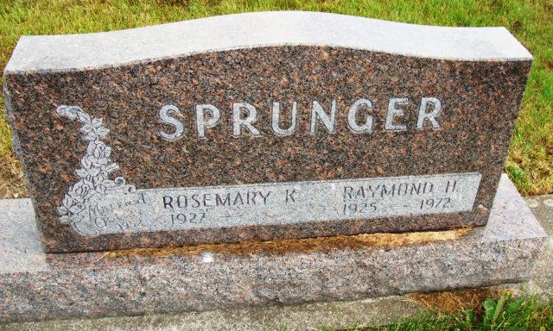
Photo by Alicia Kneuss

Rosemary K. (Sprunger) Wiederkehr, 91, of Berne, Indiana passed away Monday afternoon, February 25, 2019 at Swiss Village. She was born on November 24, 1927 in Adams County, Indiana to Homer and Della (Sprunger) Hanni. On October 25, 1952, Rosemary married Raymond H. Sprunger at the First Mennonite Church in Berne and he preceded her in death in 1972. She married Gareth L. Wiederkehr on February 4, 1989 at the First Missionary Church in Berne and he survives.
She was a member of the First Missionary Church in Berne where she helped in the children’s department. Rosemary was a 1945 graduate of Berne High School in 1945. She worked as an assistant for Dr. Amos Reusser and Dr. Howard Luginbill in Berne. For many years she was a licensed practical nurse at Caylor Nickel Hospital in Bluffton. Rosemary loved her grandchildren and enjoyed attending their activities. She enjoyed shopping, reading and needlework.
She is survived by her husband, Gareth L. Wiederkehr of Berne; son, Gregg (Barb) Sprunger of Berne; daughter, Janet (Duane) Gerig of Knoxville, TN; two step-daughters, Karen (Paul) Patton of Butler & Anne (Leon) Amstutz of Mishawaka; step-son, Wes (Lori) Wiederkehr of New Haven; six grandchildren, Leslie (Jason) King, Ben (Lana) Sprunger, Michael (Jenn) Sprunger, Jennifer (Ryan) Strutz, Stephanie (Anthony) Dee and Jon Gerig; 18 great-grandchildren, Savannah King, Janessa King, Javin King, Colton Frauhiger, Dakota (Carrie) Frauhiger, Samuel Frauhiger, Hallie Frauhiger, Eva Sprunger, Isaac Sprunger, Eden Sprunger, Myriam Sprunger, David Sprunger, Jackson Strutz, Ryleigh Strutz, Marin Rose Strutz, Mackenzie Dee, Penelope Dee and William Dee. There are also six step-grandchildren and nine step-great-grandchildren.
She was preceded in death by her parents; a sister, Gloria (Hanni) Kuhn; & a brother, Vincent Hanni.
A funeral service will be held at 11:00 a.m. Saturday, March 2, 2019 at the First Missionary Church in Berne with Pastor David Biberstein and her grandson, Pastor Michael Sprunger, officiating. Burial will follow at MRE Cemetery in Berne. Family & friends will be received from 2 to 8 p.m. Friday, March 1, 2019 at the First Missionary Church in Berne and from 9:30 to 11 a.m. Saturday prior to the service at the church.
Preferred memorials are to First Missionary Church Children’s Ministry or checks to SIM USA with a note for missionaries Alan & Cheri Shea (Gareth’s granddaughter), PO Box 7900, Charlotte, NC 28241.

Zwick & Jahn Funeral Homes, Adams County, Indiana

