Rose Sprunger
March 2, 1892 – April 15, 1967

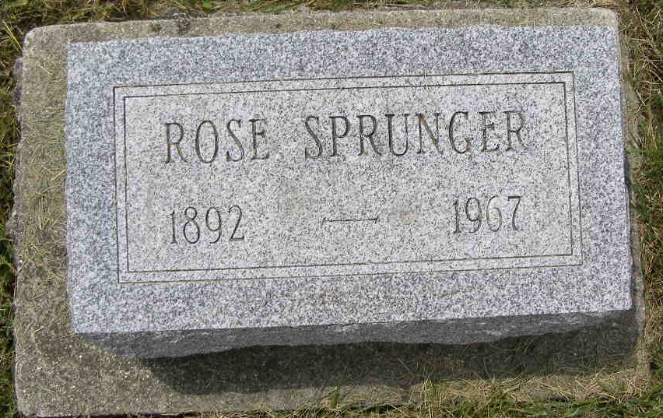
Photo by Shaunda Bedwell Opdycke

Rose Sprunger, Retired School Teacher Dies
Funeral Here Tuesday for Local Woman, 75

Miss Rose Sprunger, 75, 506 West Franklin Street, died at 6:10 pm Saturday at Lutheran Hospital in Fort Wayne where she had been a patient several weeks. She had been in failing health several years following a heart attack and ill since February 23.
Miss Sprunger, widely known, was a retired school teacher. She taught the second grade in the Berne Schools for 33 years, two years at District No. 8 in Wabash Township and two years at Wadsworth, Ohio, or a total of 37 years.
She received her education at Bluffton College and Ball State Teachers College. A native of Monroe Township, Miss Sprunger was born March 2, 1892, a daughter of Frederick and Katherine Sprunger Sprunger. She was a member of the First Mennonite Church and active in church work for many years.
Surviving are three sisters, Milka and Alina Sprunger, both of Berne and Mrs. J. C. (Bertha) Kaufman, Freeman, S.D. Three brothers, Daniel, Otto and Ira and four sisters, Mary Ann, Dina, Hannah and Emma preceded in death.
The body is at the Yager Funeral Home where friends may call and where services will be held at 2 pm. Tuesday. Rev. Gordon Neuenschwander will officiate and burial will be in the MRE Cemetery.

Date of Death: Tuesday, April 16, 1967 Date of Burial: April 18, 1967 Burial: Lot 254 – Orig. Platt

Berne Library Heritage Room (IN)
MRE Obits 1966 – 1972, image 71

