Romaine Maxine (Lehman) Sprunger
May 4, 1928 – April 14, 2002
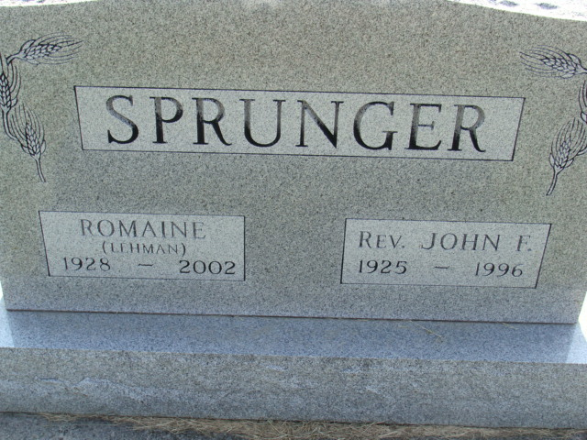
Photo by Alicia Kneuss

Romaine M. Sprunger, 73, of Berne, an elementary school teacher, died Sunday, April 14, 2002, at Swiss Village. The Adams County native had taught in Decatur and in Pennsylvania. She was a member of First Mennonite Church and helped her husband with his ministry for 43 years. Surviving are sons Rev. Timothy and Thomas, both of Berne, and Rev. Robert of New Haven; her mother, Edna Habegger of Berne; brothers Maynard, Claren and Doyle Lehman, all of Berne; a foster sister, Kay Miller of Kodak, Tenn.; and six grandchildren. Her husband, Rev. John, and a brother preceded her in death. Memorial services are 11 a.m. Saturday at First Mennonite Church, Berne. Calling is from 1 to 8 p.m. Thursday at Yager-Kirchhofer Funeral Home, Berne. Burial will be at MRE Cemetery, Berne. Memorials are to Great Lakes Discipleship Center or Creative Access Associates. Information provided by Yager-Kirchhofer Funeral Home, Berne.

News-Sentinel, The (Allen County, Indiana)
Tuesday, April 16, 2002

