Roger L. Sprunger
April 4, 1920 – December 12, 2008

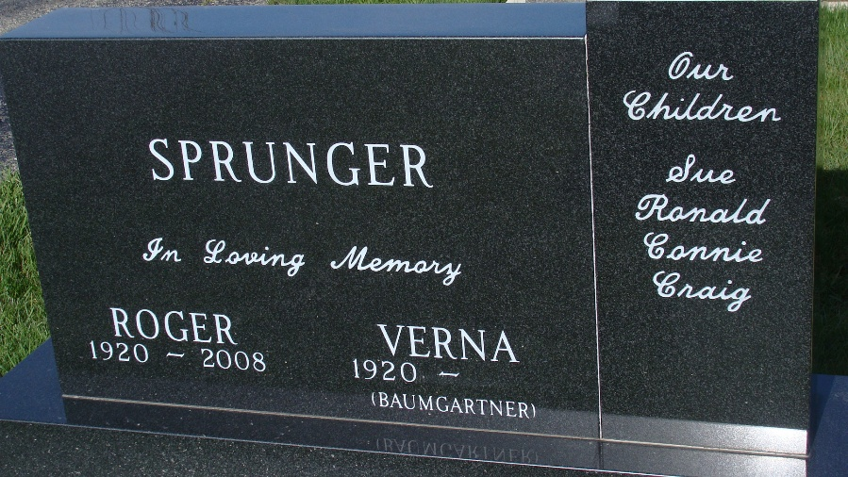
Photo by Alicia Kneuss

Roger L. Sprunger, 88, a resident of Berne, Indiana passed away at 9:39 a.m. Friday, December 12, 2008 in the Swiss Village Retirement Community in Berne, Indiana. Roger was born on April 4, 1920 the son of Franklin and Nan (Eckrote) Sprunger, both deceased. He married Verna Baumgartner on November 7, 1942 and she survives.
Roger was a member of the First Mennonite Church in Berne, Indiana where he sang in the Chancel Choir, Mens Chorus, Oratorios, and served on many church committees.
Roger served in the U.S. Army for three and one half years during World War II. He was a graduate of Kendall School of Design in Grand Rapids, Michigan and was resident designer of Dunbar Furniture for twenty-five years. He continued his profession in the furniture business as Sales and Design coordinator for Berne Furniture until his retirement in April of 1990. He also served as design coordinator at Swiss Village Retirement Center for twenty-nine years and was active on the Swiss Heritage committee. In 2003, Roger was selected as the Grand Marshall during Swiss Days in honor of the many Swiss style store fronts he designed in Berne.
Surviving in addition to his wife Verna are two sons, Ronald (Karleen) Sprunger and Craig (Lora) Sprunger both of Berne, Indiana; two daughters, Sue (James) Bergstrom of Lafayette, Indiana and Constance (David) Sewell of Columbia City, Indiana; and one sister, Gretchen (Richard) Lehman of Pandora, Ohio. Other survivors include ten grandchildren and seven great-grandchildren. Roger was preceded in death by three brothers, Donald, Deryll, Jethro B., and one sister, Delores (Merlin) Habegger of Roscoe, Illinois.
Funeral services will be held 11:00 a.m. Tuesday, December 16. 2008 in the First Mennonite Church in Berne, Indiana with Pastor Jerry Flueckiger, Pastor Dennis Schmidt, and Pastor Anita Rediger officiating. Interment will follow in the M.R.E. Cemetery of rural Berne, Indiana. Friends and family will be received from 2:00 – 8:00 p.m. Monday, December 15, 2008 at Swiss Village and one hour prior to the service at the church on Tuesday. Preferred memorials are to the First Mennonite Church or Swiss Village.

Yager-Kirchhofer Funeral Home, Adams County, Indiana

