Robertine M. (Liechty) Sprunger
November 23, 1882 – April 5, 1953

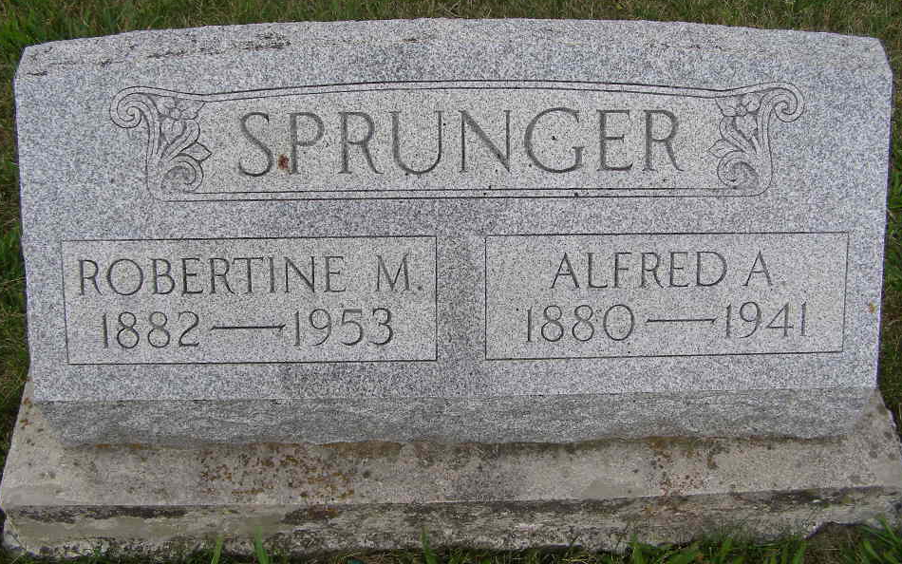
Photo by Shaunda Bedwell Opdycke

Indiana, U.S., Death Certificates, 1899-2017

Name Robertine Sprunger
[Robertine Liechty]
Gender Female
Race White
Marital Status Widow
Age 70
Birth Date 23 Nov 1882
Birth Place Indiana, Adams County
Death Date 5 Apr 1953
Death Place Berne, Adams, Indiana, USA
Death Registration Date 1953
Father Emanuel J Liechty
Mother Anna Sprunger
Informant Arthur Sprunger
Burial 4/8/1953 M. R. E. Cemetery
**

Indiana, U.S., Marriages, 1810-2001

Name Robertina Lichty
Gender Female
Race White
Event Type Marriage Registration (Marriage)
Birth Place Berne, Indiana
Marriage Date 1 Jan 1903
Marriage Place Berne, Indiana, United States
Residence Place Berne, Indiana
Father E J Lichty
Mother Springer
Spouse Alfred Springer
Page 135

