Robert L. Sprunger
October 3, 1885 – March 7, 1969

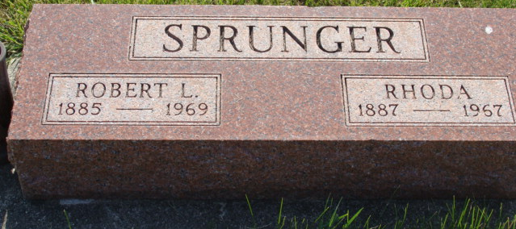
Photo by Alicia Kneuss

Prominent Local Man Dies Friday Following Surgery

Robert L Sprunger, 83, retired carpenter and for many years, a resident of Berne, died at 3:25 PM Friday at the Bluffton Clinic Hospital, where he recently submitted to major surgery. Death was attributed to congestive heart failure.
For the past 18 months, he was a resident of the Mennonite Memorial Home in Bluffton, Ohio. He and his family resided on N. Jefferson St. here for many years, and he was a lifelong resident of Adams County. Mr. Sprunger operated a store in Monroe for a number of years before moving to Berne. For many years, he was employed in carpentry and construction work.
He was born in this community October 3, 1885, the son of Philip and Anna Lehman Sprunger. He was married in June 1912 to Rhoda Liechty who preceded him in death, April 22, 1967.
Surviving are 6 sons, Donald J. Sprunger, Fort Wayne; Dr. Edgar P Sprunger, Berne; Eugene, Berne; Roy, Berne, Rev. John Sprunger, Holland, Pennsylvania, and Rev. Sam Sprunger, Marcellus, Michigan; a daughter, Mrs. James Gurley, Wheaton, Illinois; 25 grandchildren and 2 great-grandchildren; a brother, Arthur, Goshen, and 3 sisters, Mrs. Menno P. Eicher and Mrs. William Norr both of this community, and Mrs. Faye Grassmeyer, Greenwood, Delaware. A son, 6 brothers and sisters, including 3 in infancy preceded in death.
Mr. Sprunger was an active member of the First Mennonite Church, served on the church board for a number of years and taught a Sunday School class for many years. Services were held at 10 AM today at the First Mennonite Church, Rev. Gordon Neuenschwander and Rev. Gerald Stucky officiating. Burial will be in the MRE Cemetery. The Yager Funeral Home had charge of the service.

Date of Death: Friday, March 7, 1969; Date of Burial: March 10, 1969 Burial: MRE – S ½ 54, Sect. 1, 5th Addition

Berne (IN) Library Heritage Room
MRE Obits 1968-1971

